**IMDB**

**STG_CREATE**

**Crew_movie EXTRACT**

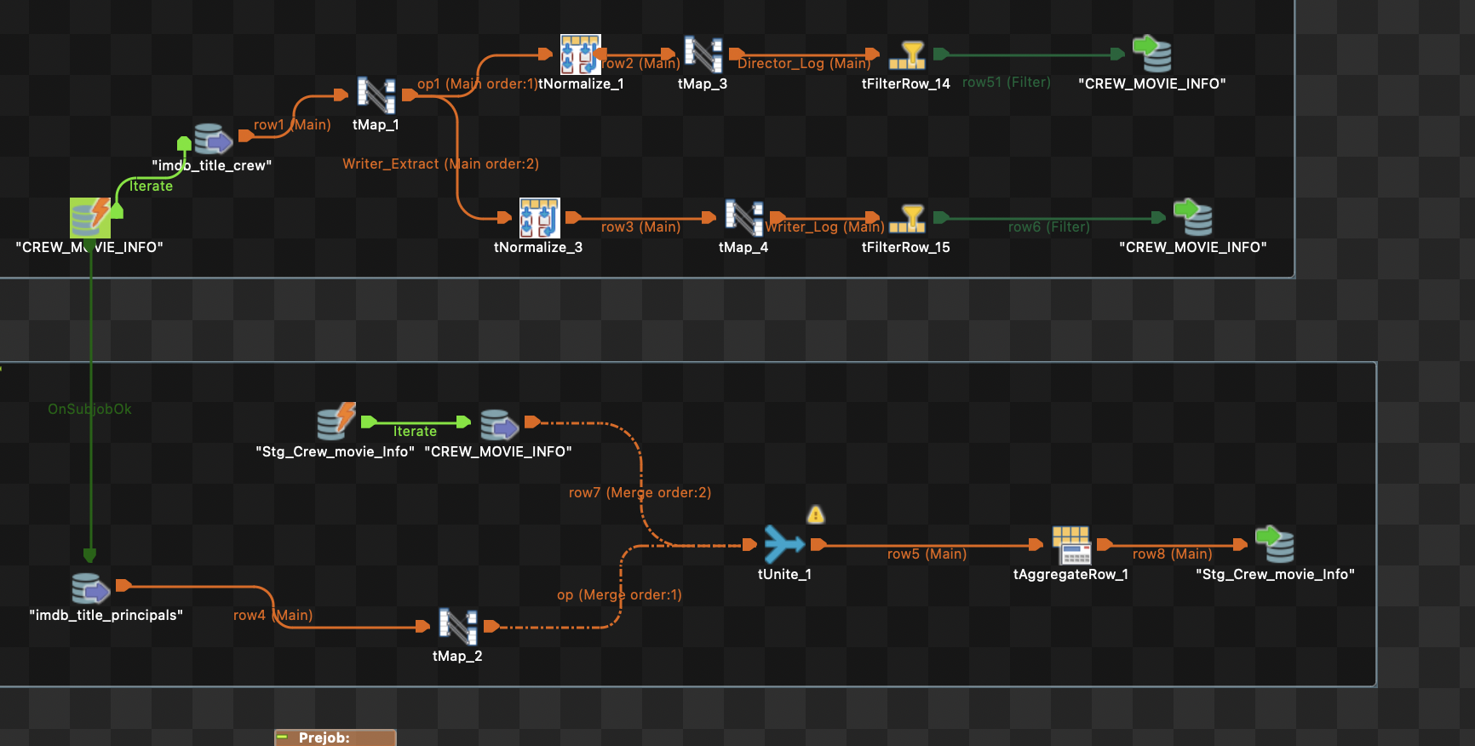

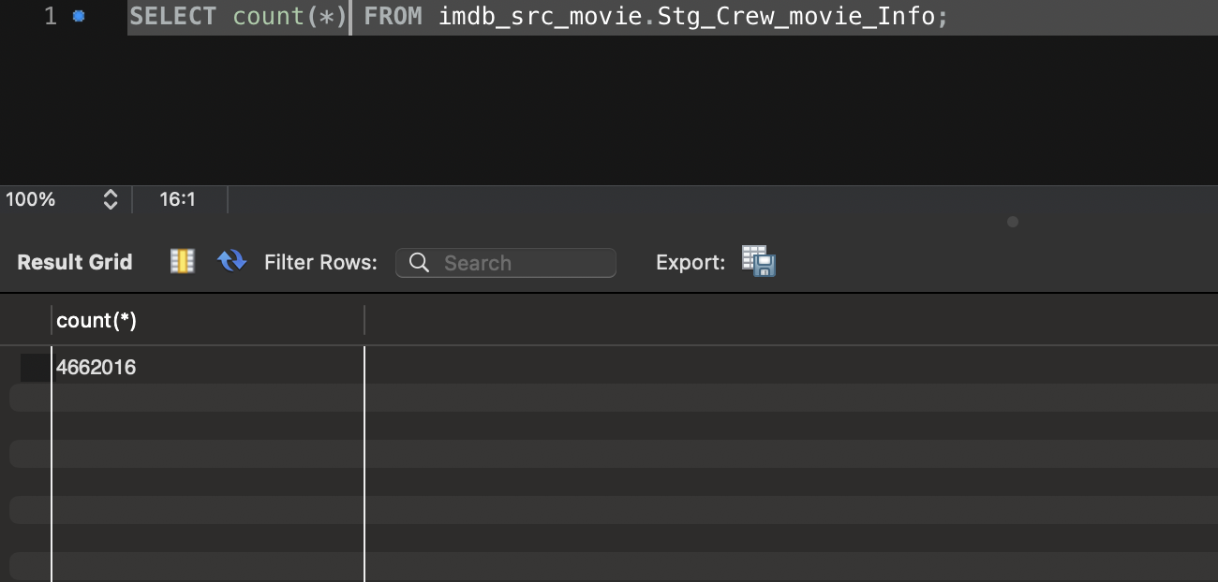

**Revenue Loading**

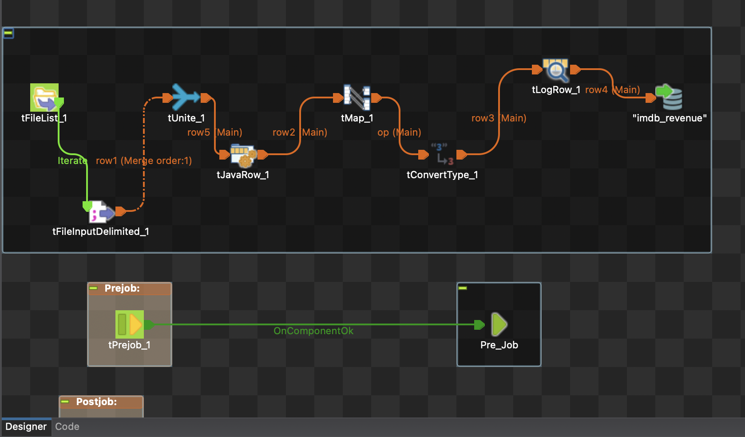

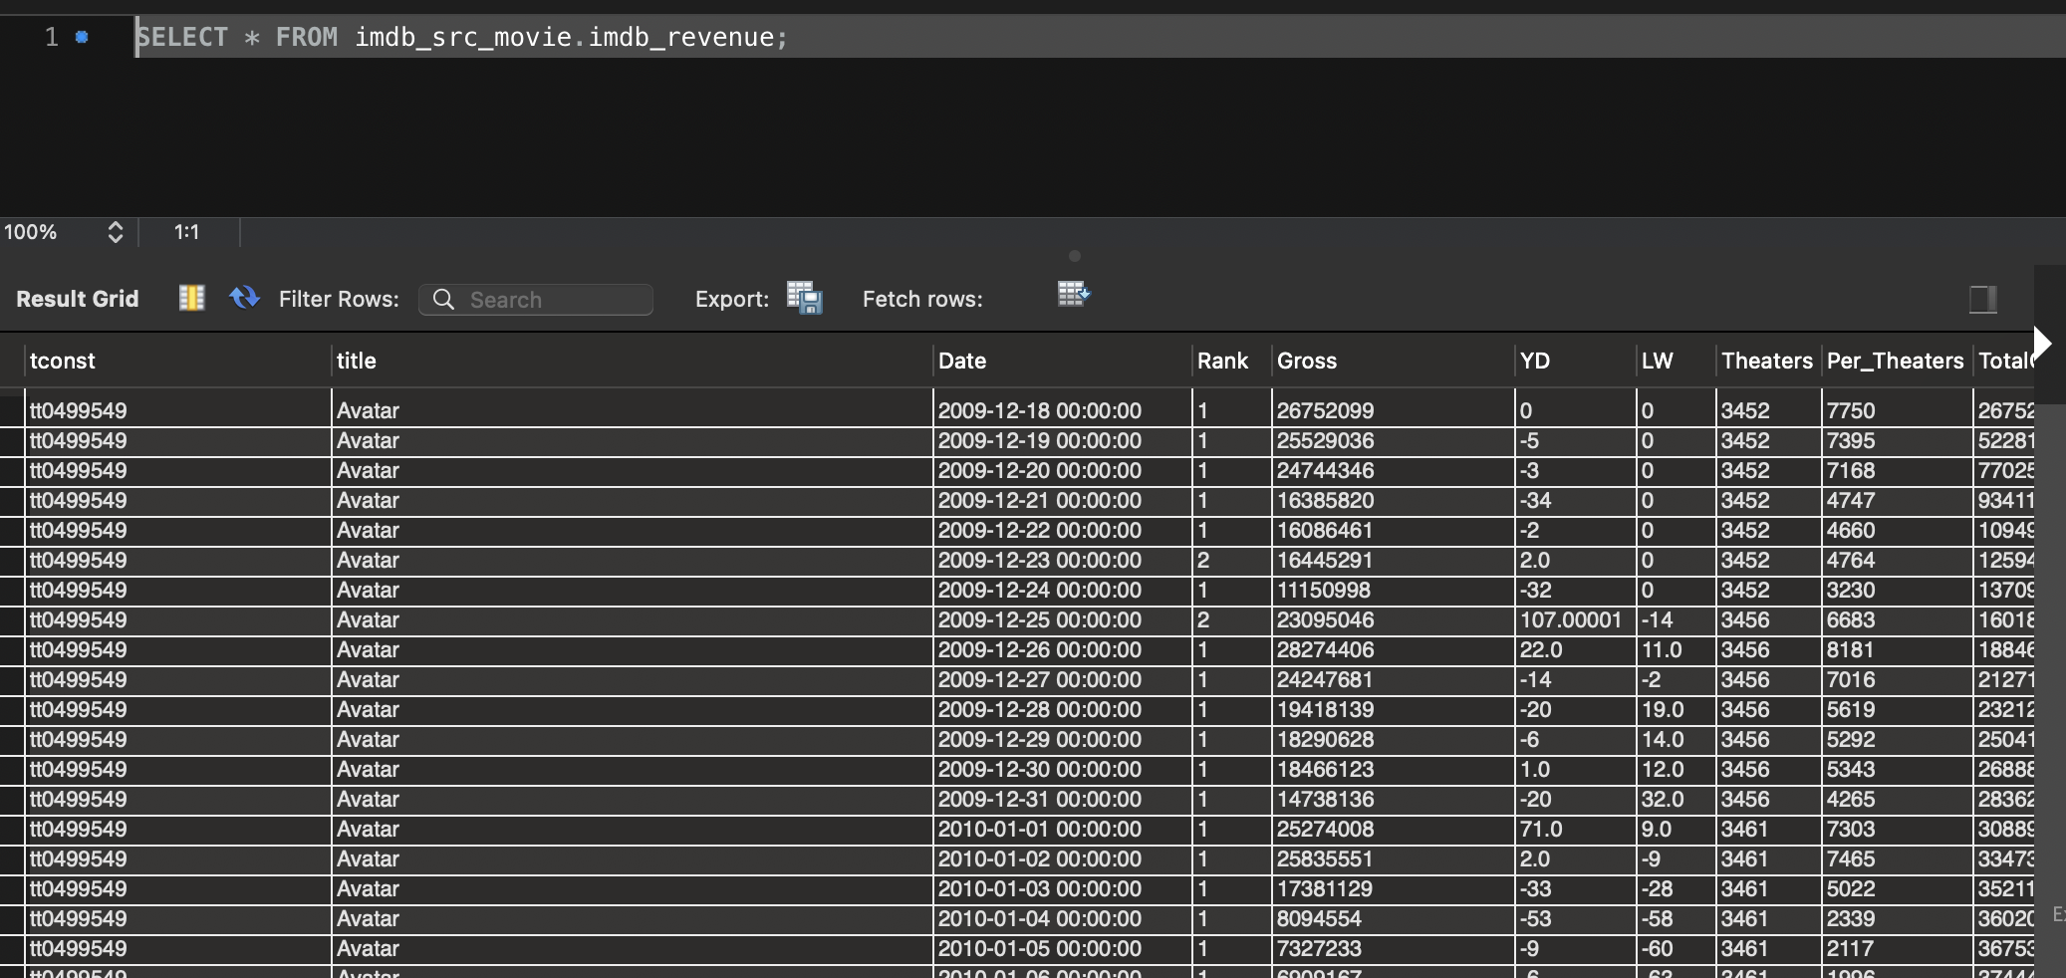

**SCD Load**

**SCD_CREW**

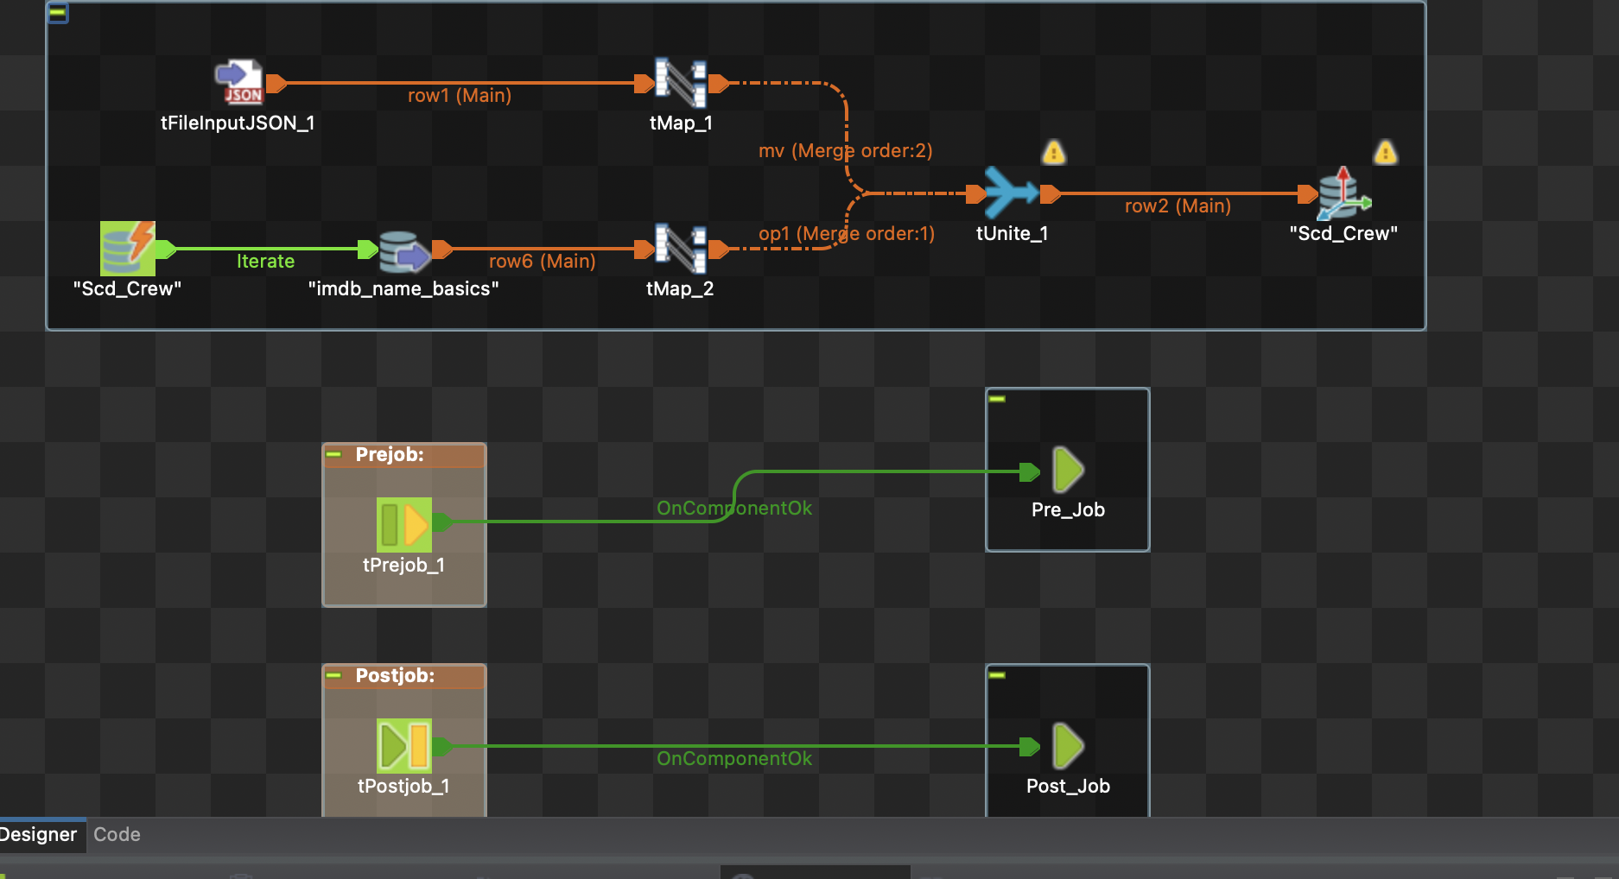

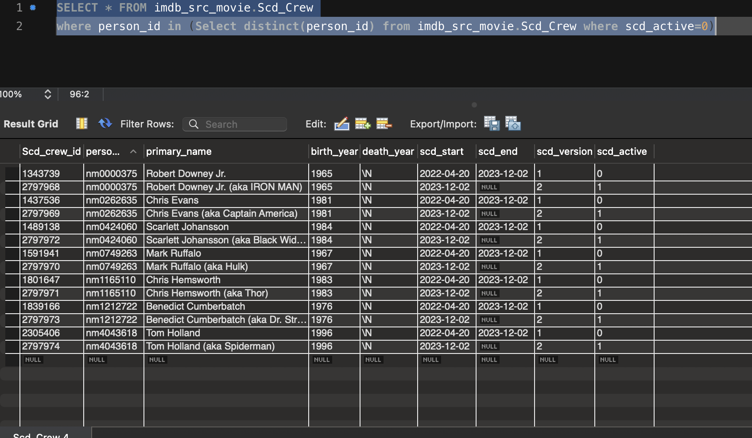

**SCD_Movie**

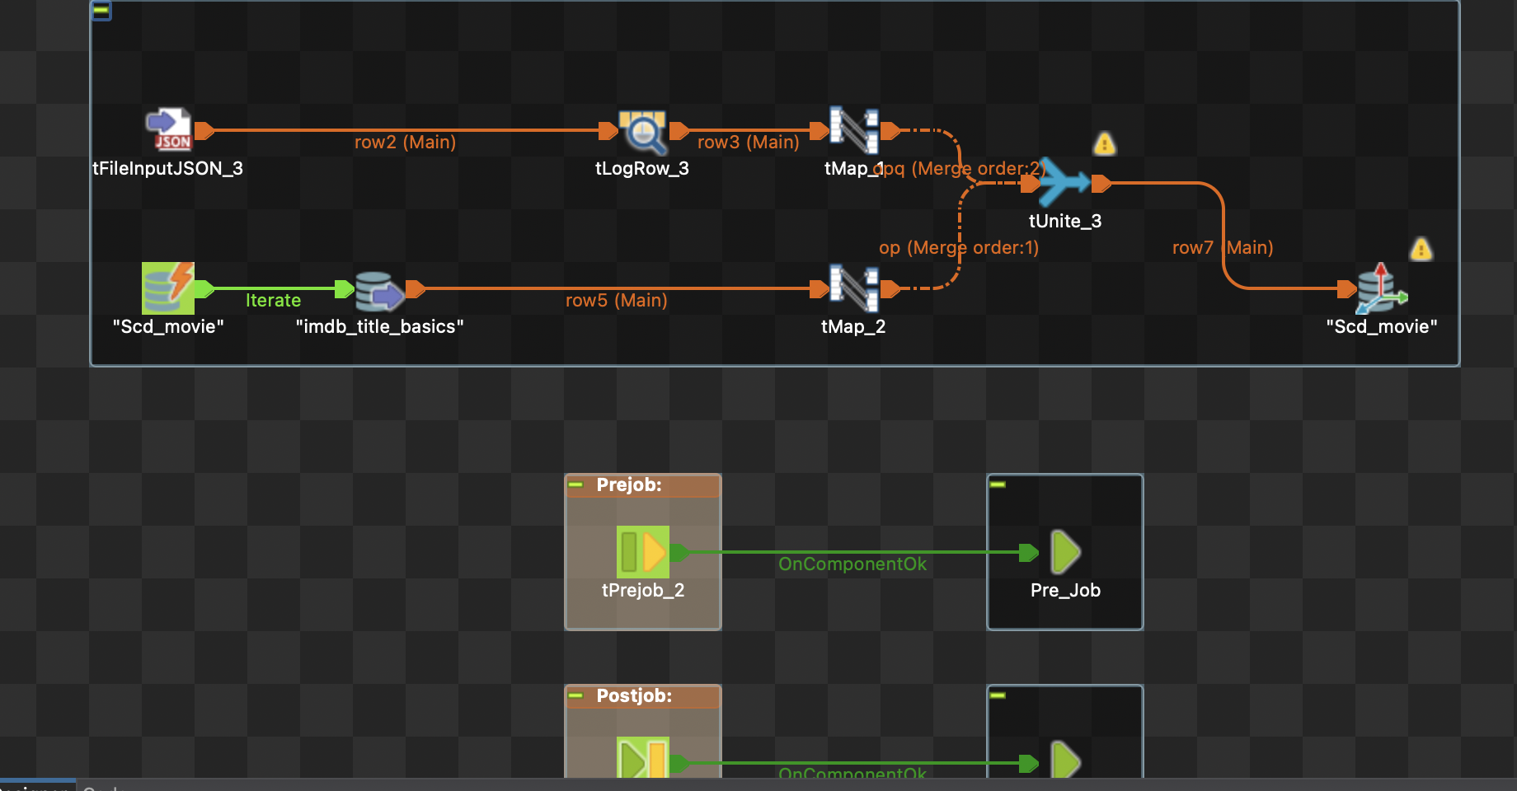

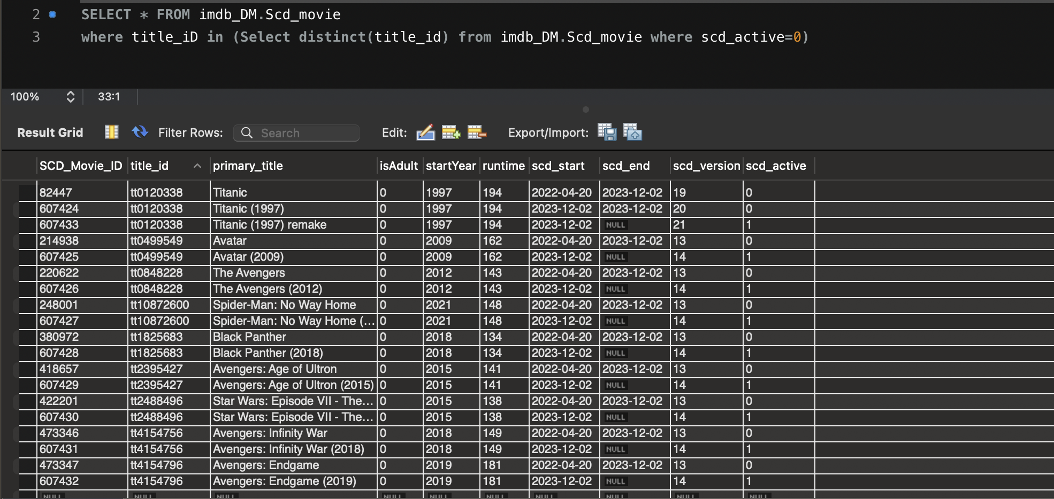

**Dim_Crew_details**

**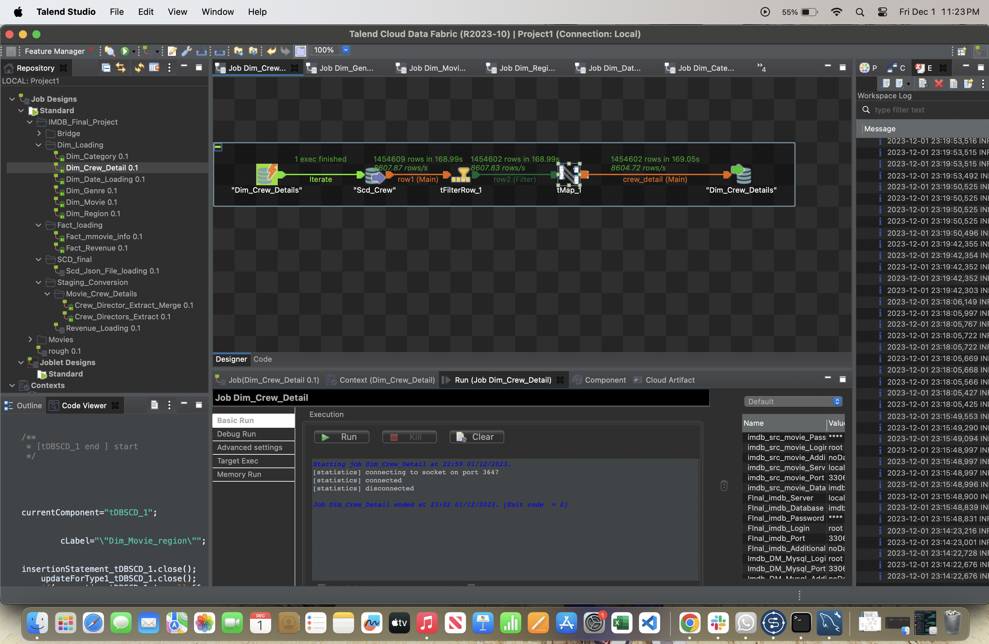  
  
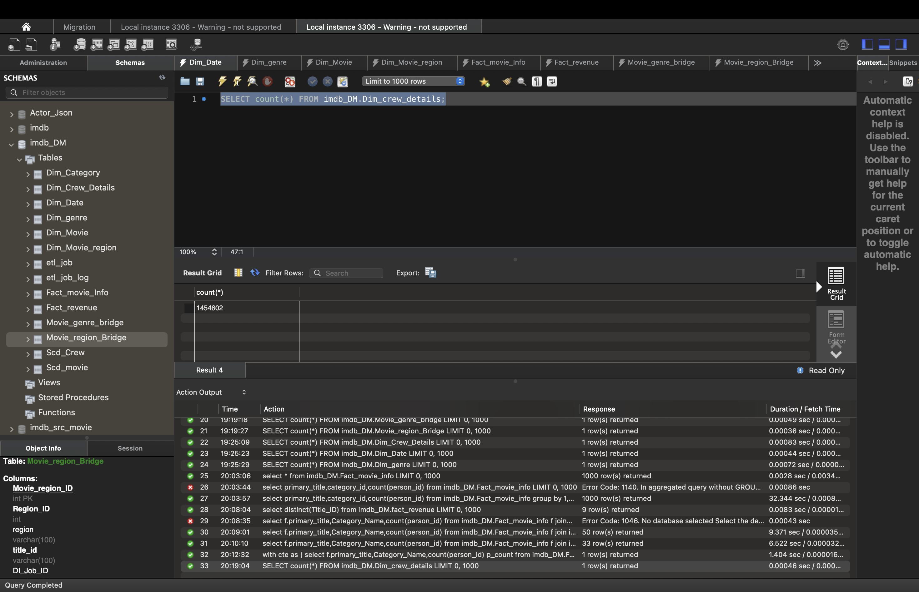**

**Dim_Category**

**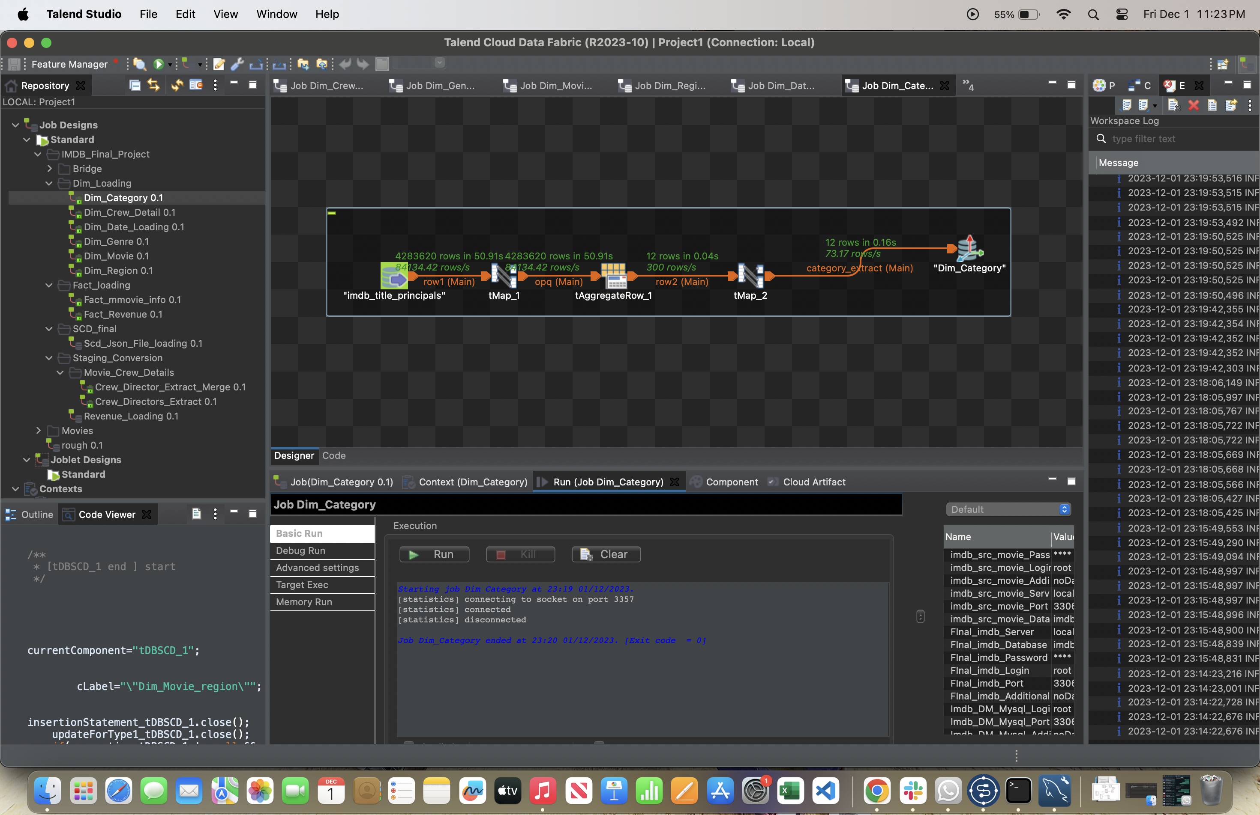  
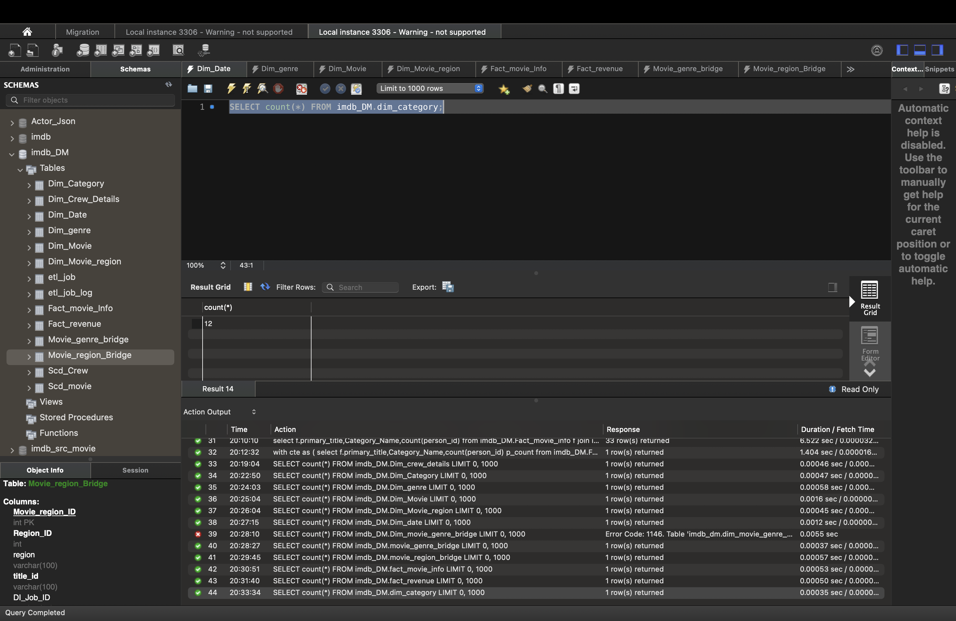**

**Dim_Genre**

**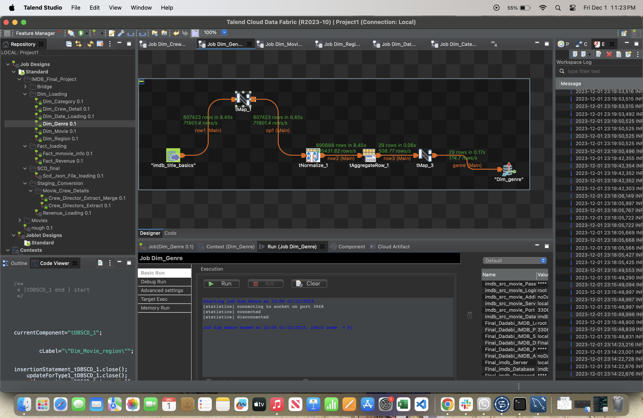  
  
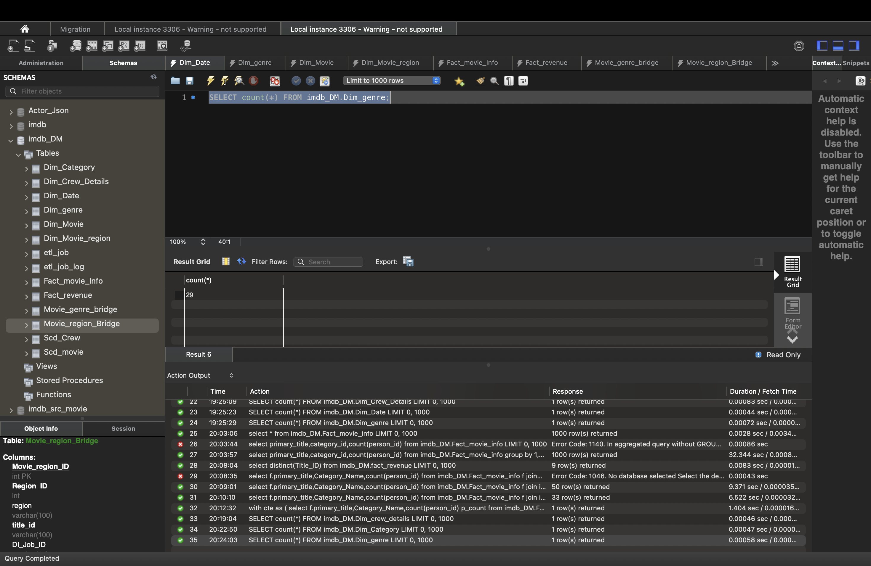**

**DIM_Movie**

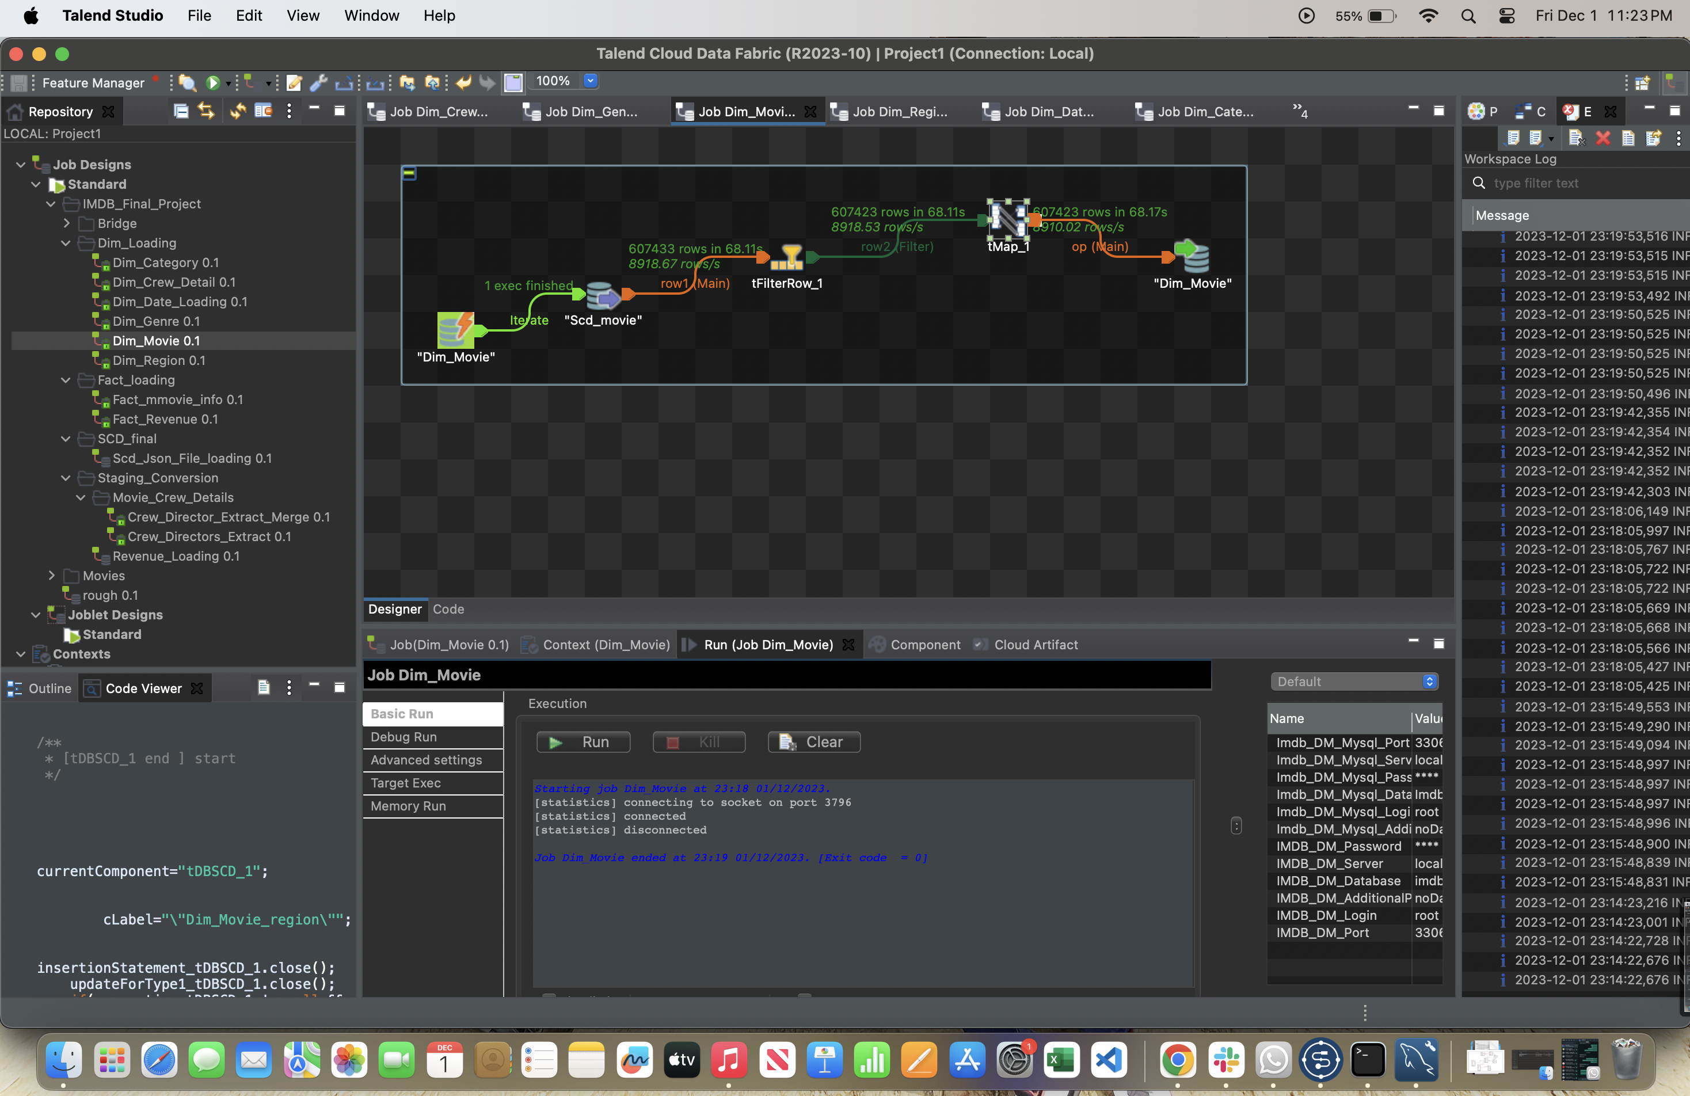

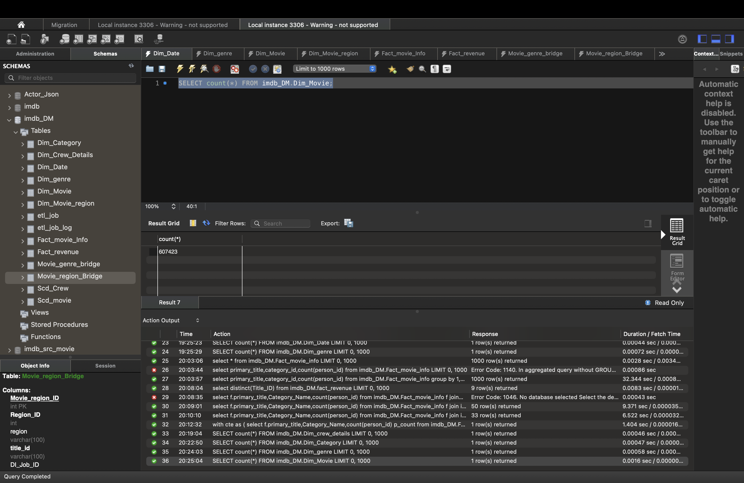

**DIM_MOVIE_REGION**

**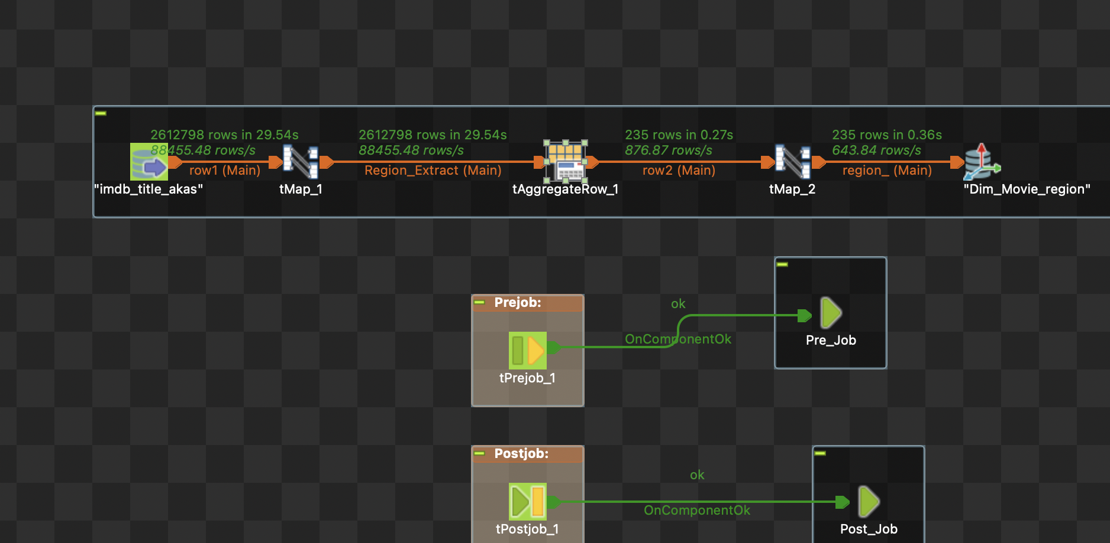  
  
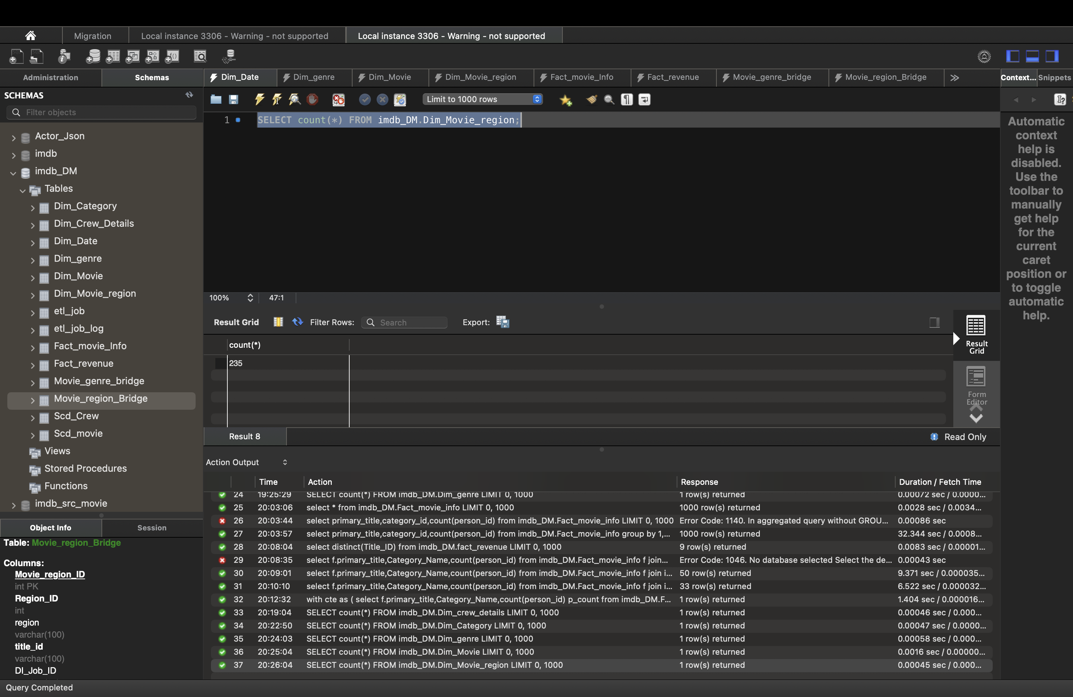**

**DIM_DATE**

**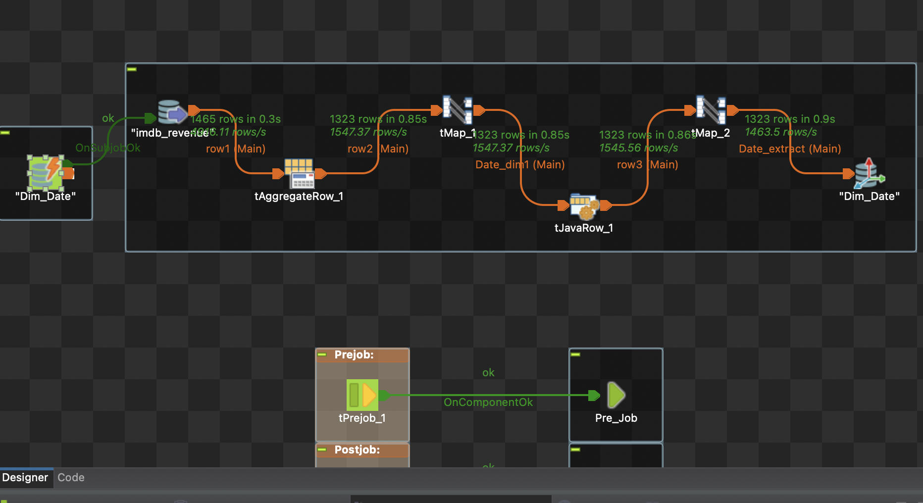  
  
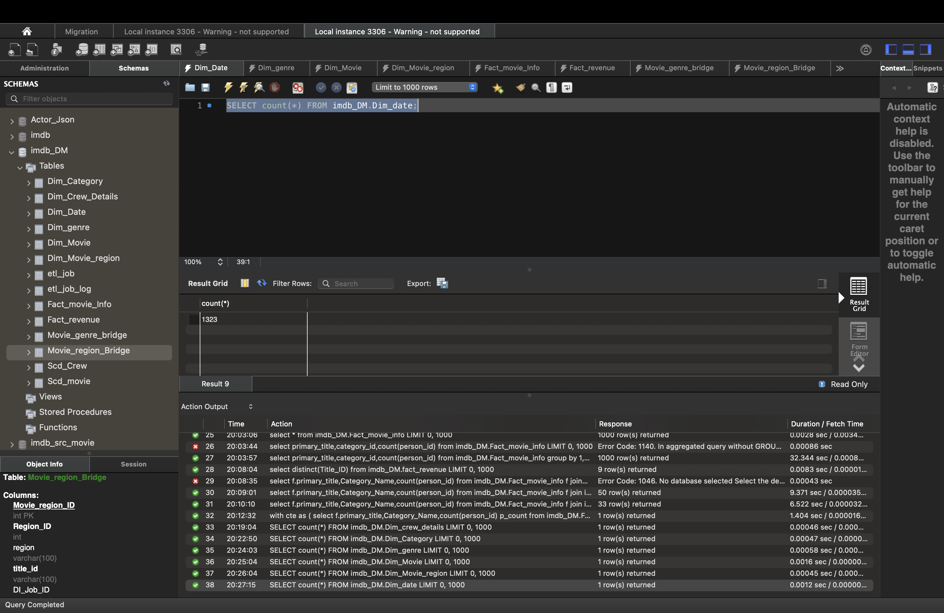**

**MOVIE_GENRE_BRIDGE**

**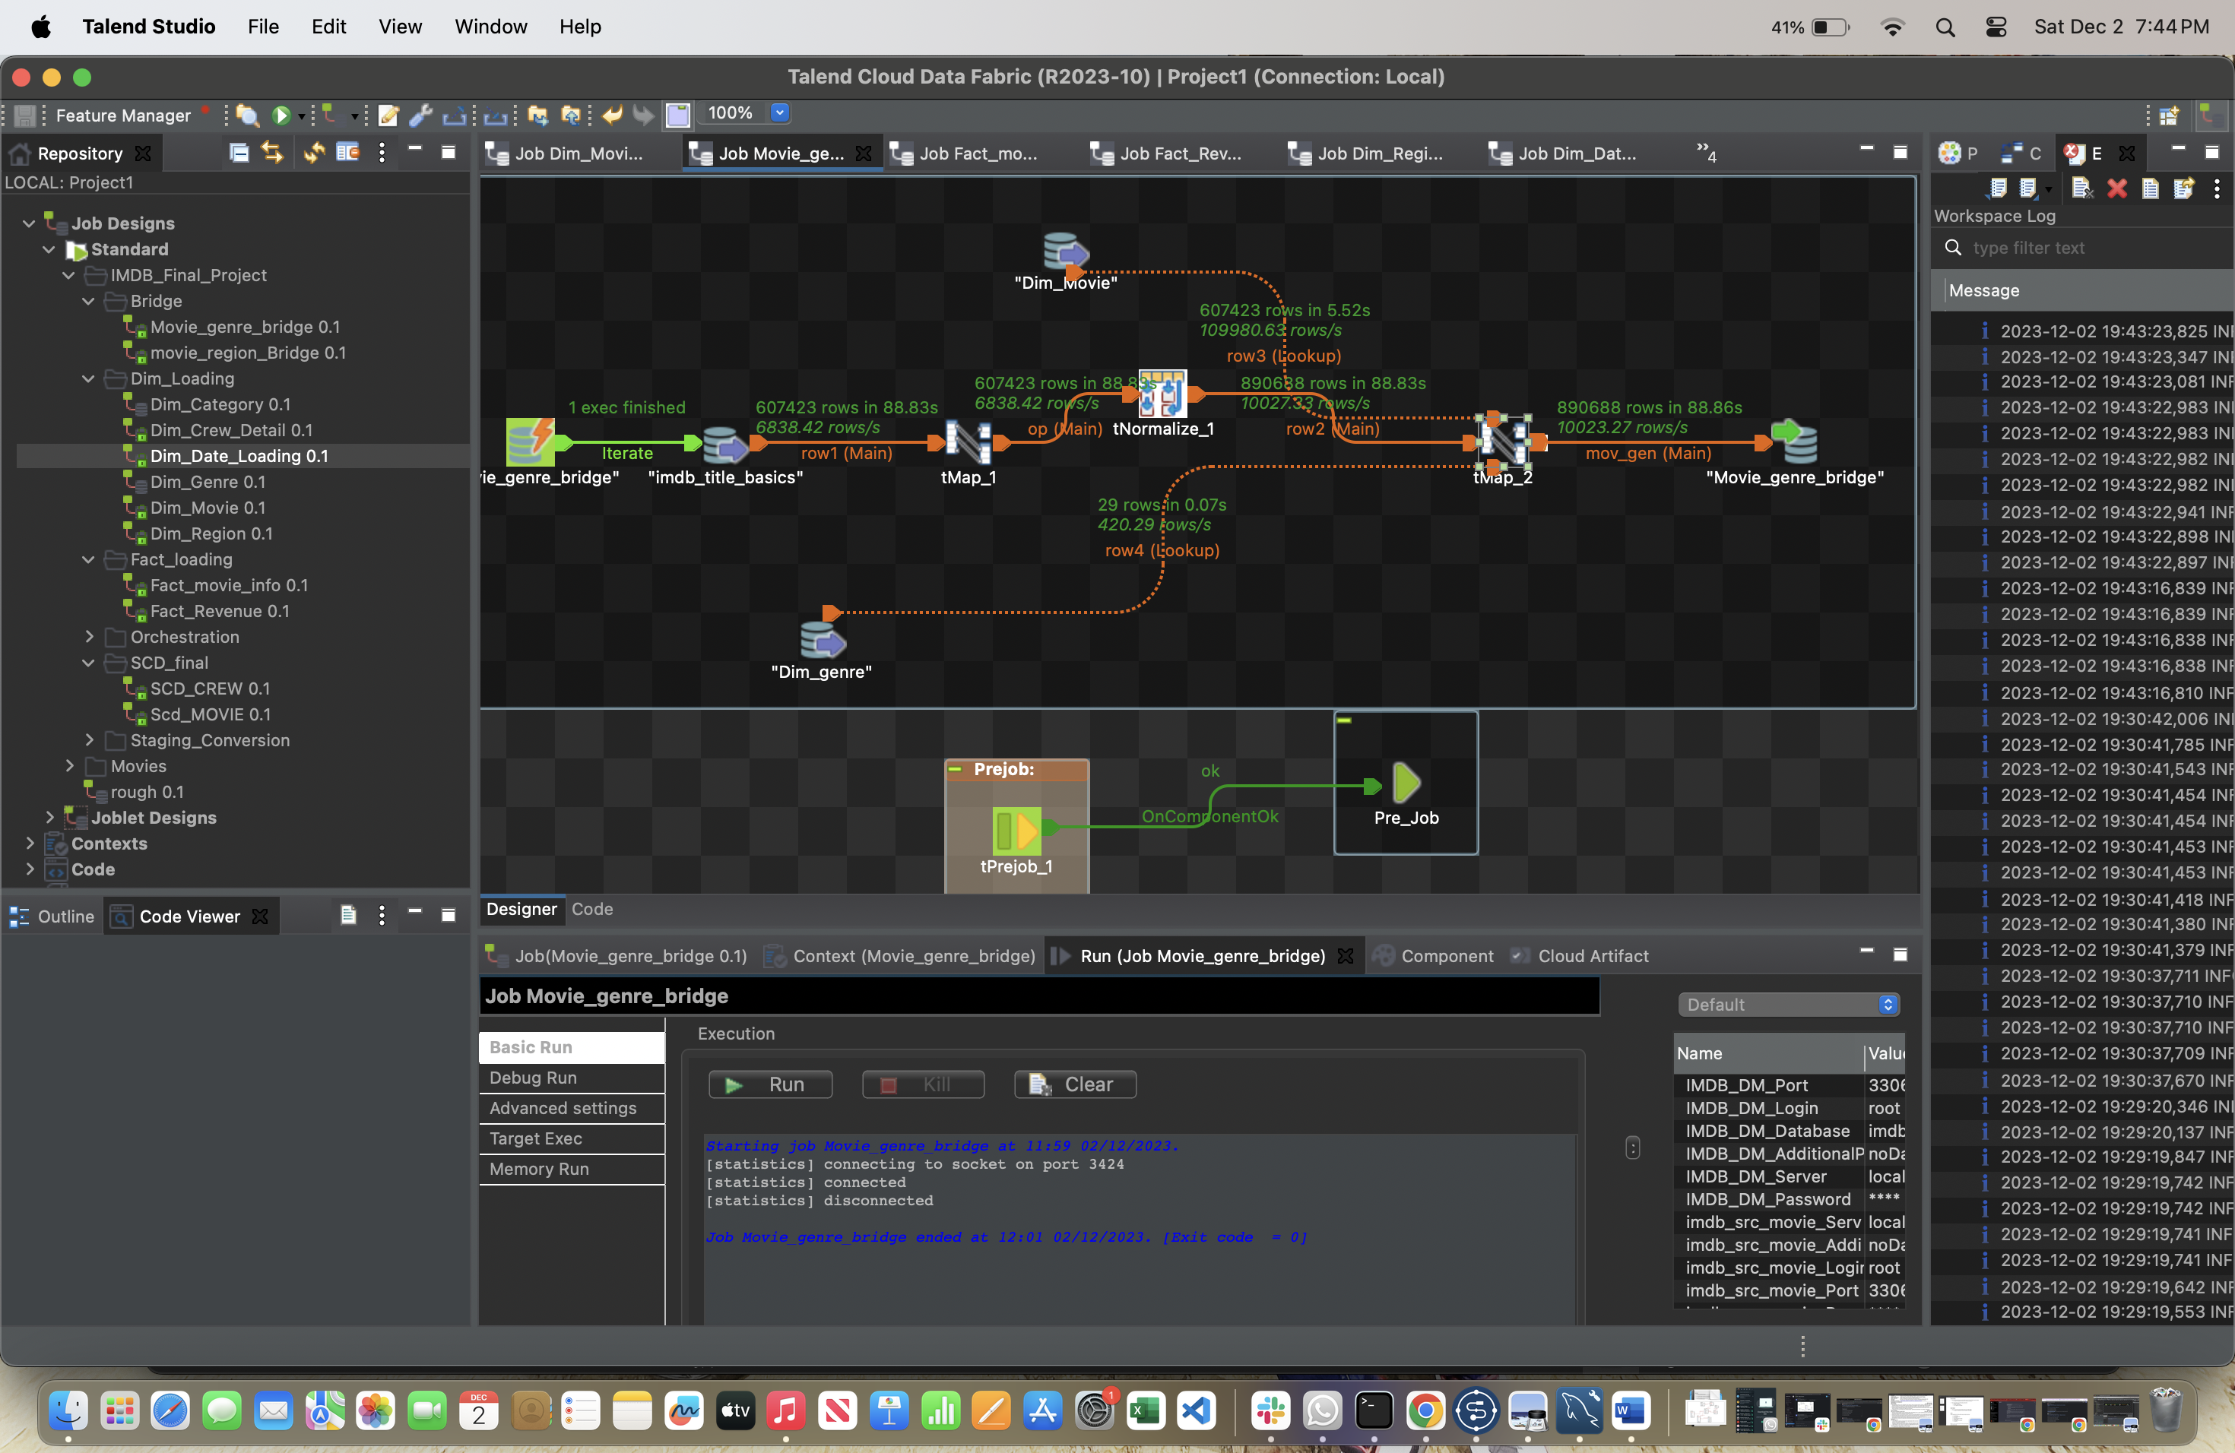  
  
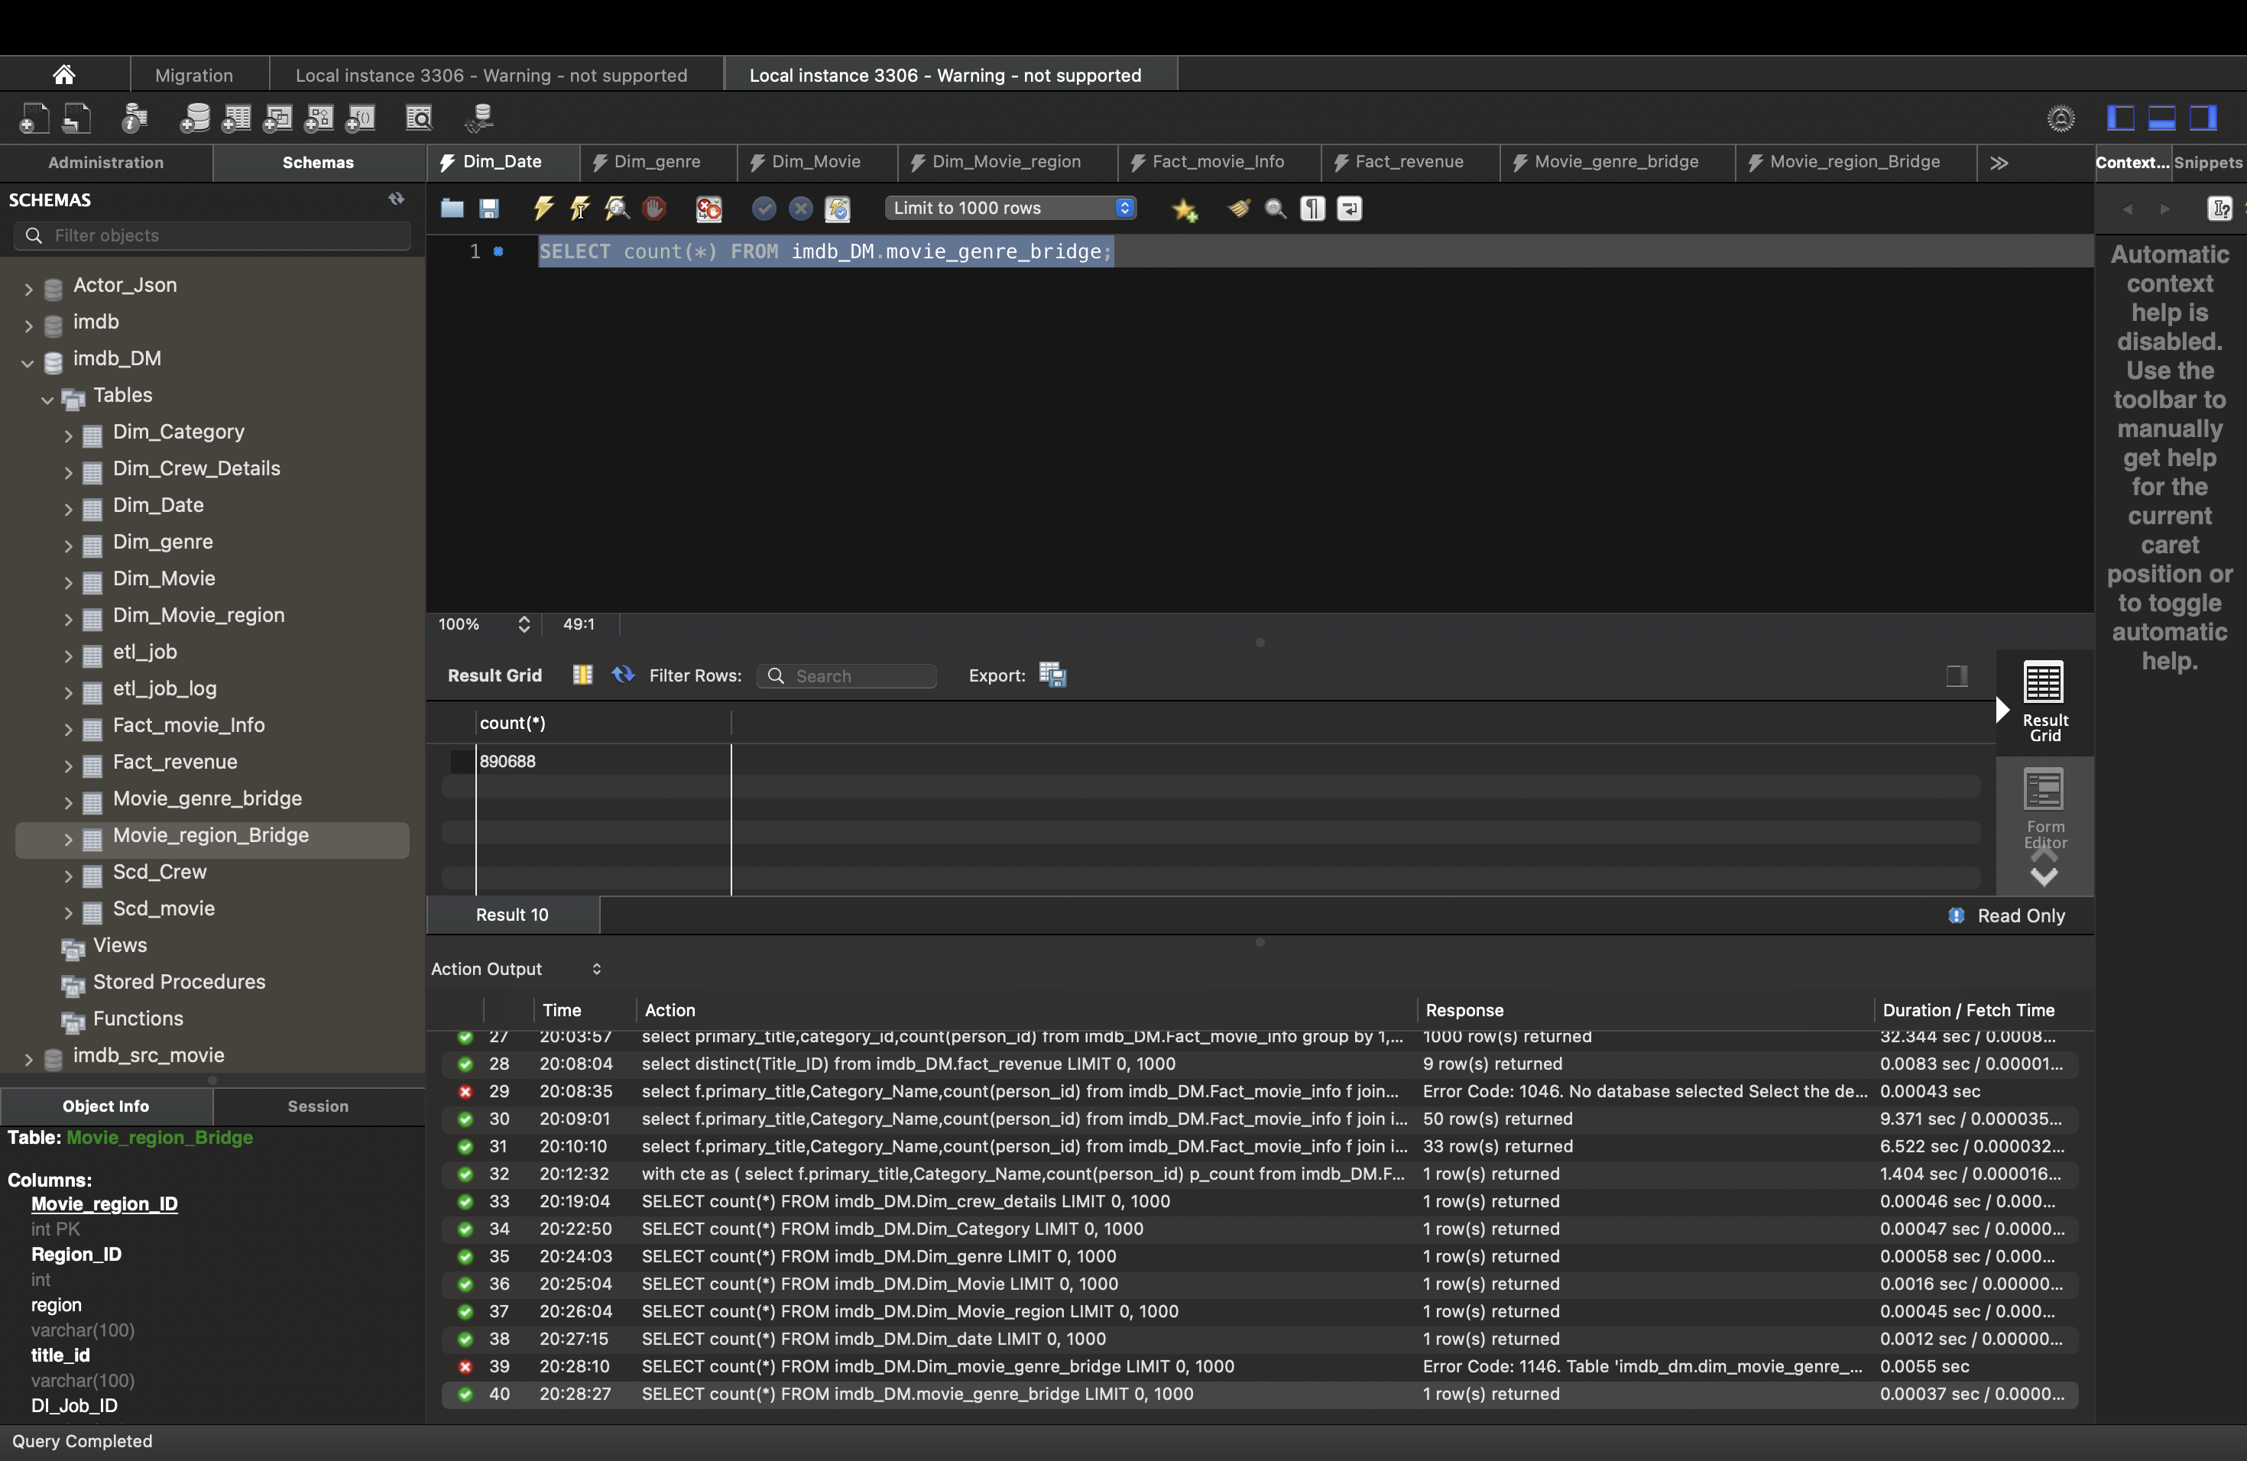**

**MOVIE_REGION_BRIDGE**

**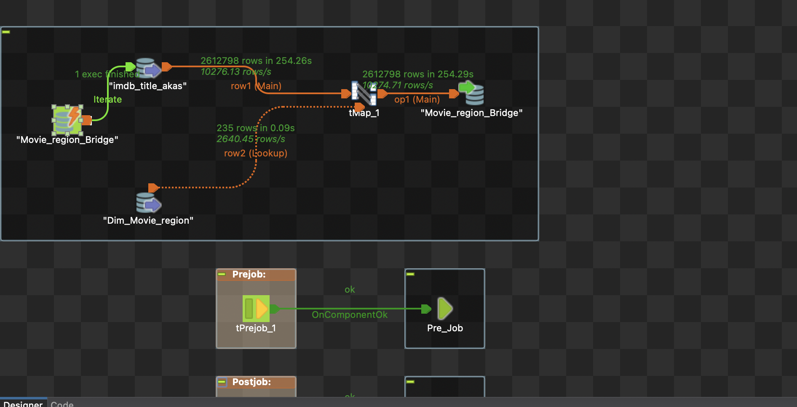  
  
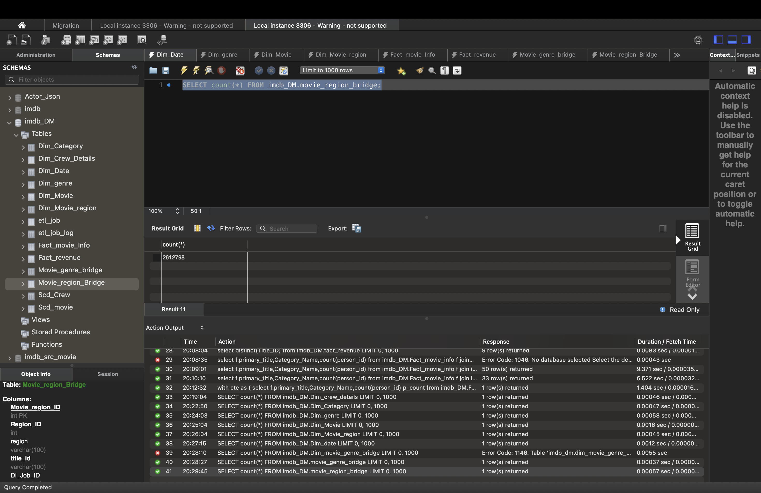**

**Fact_Movie_Info**

**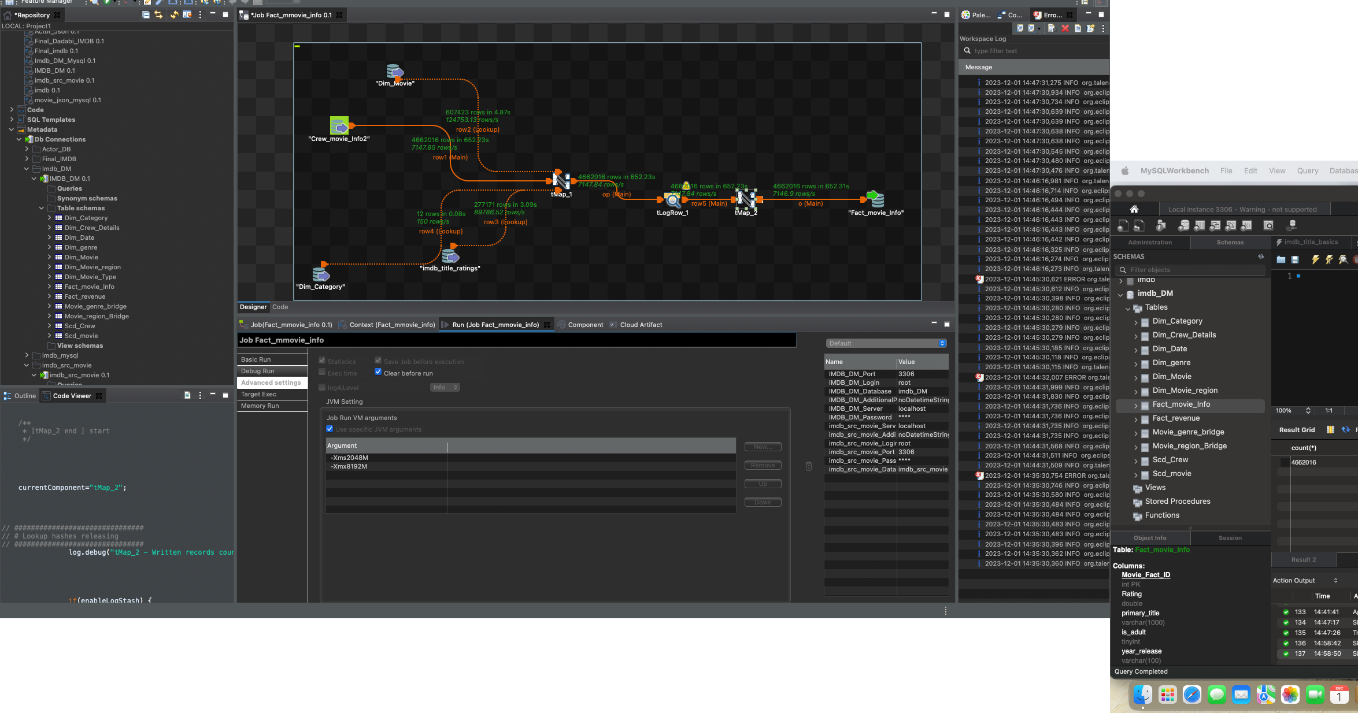  
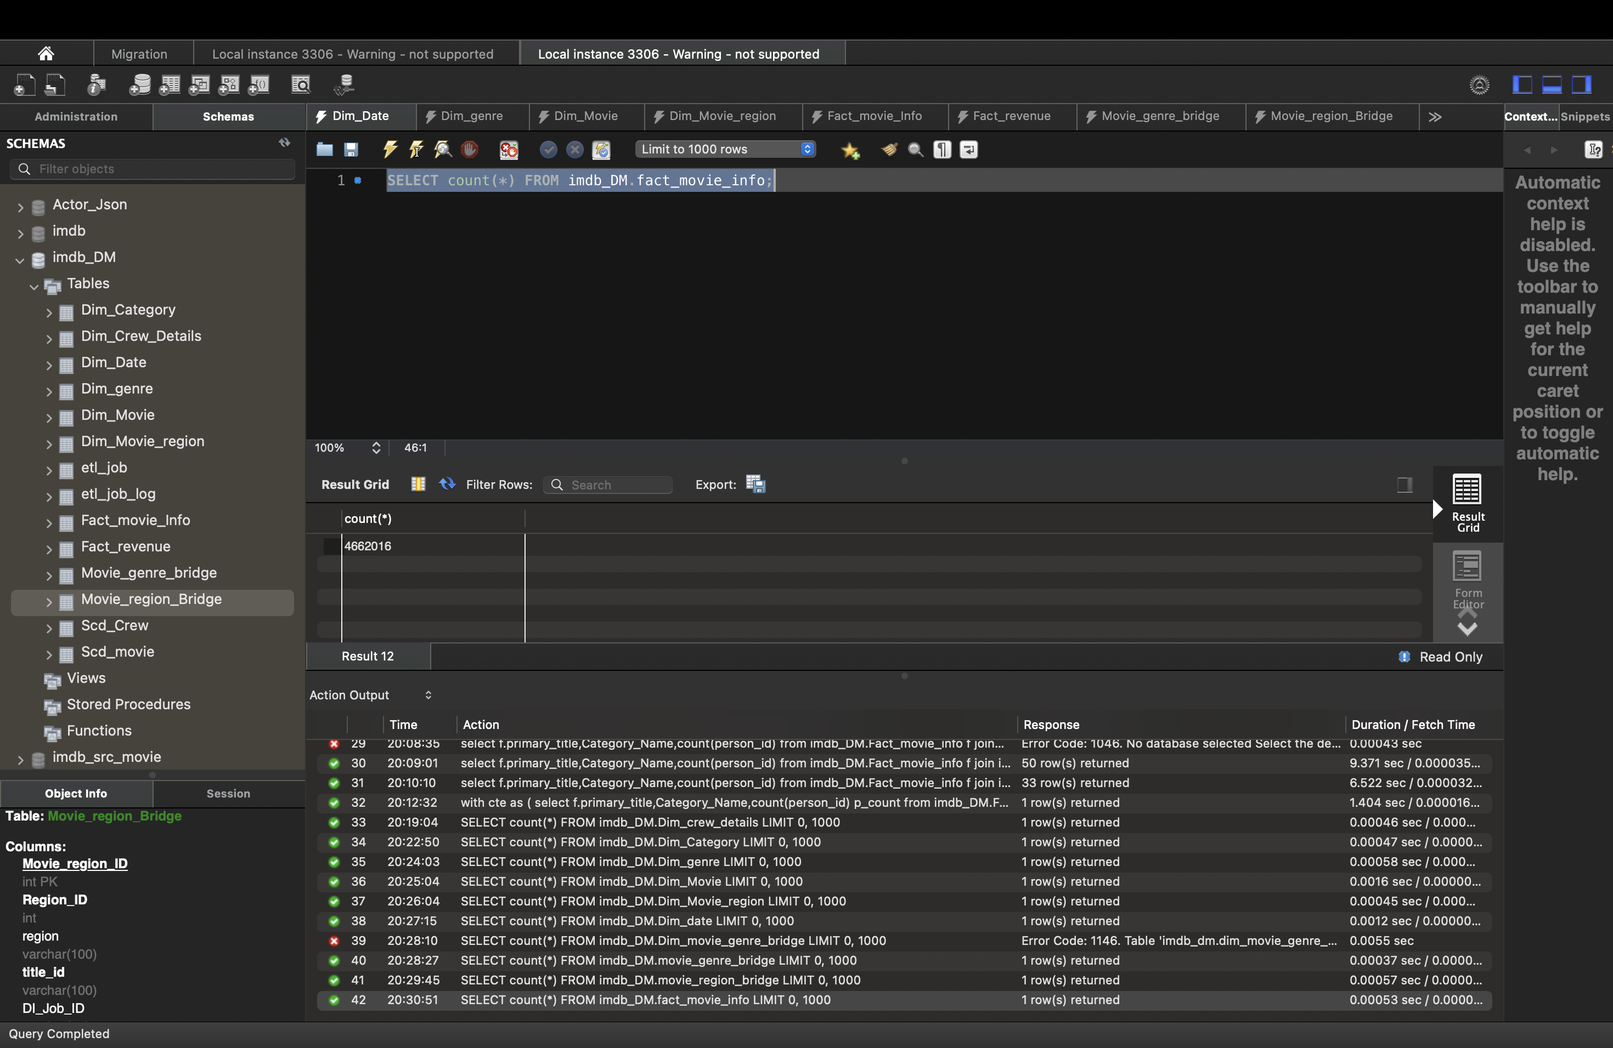**

**FACT_REVENUE**

**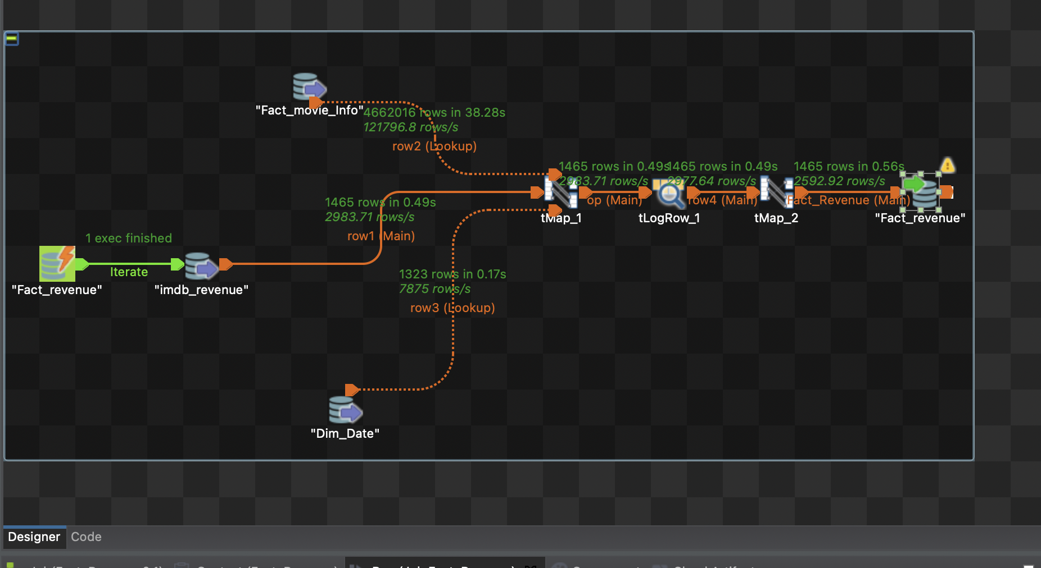  
  
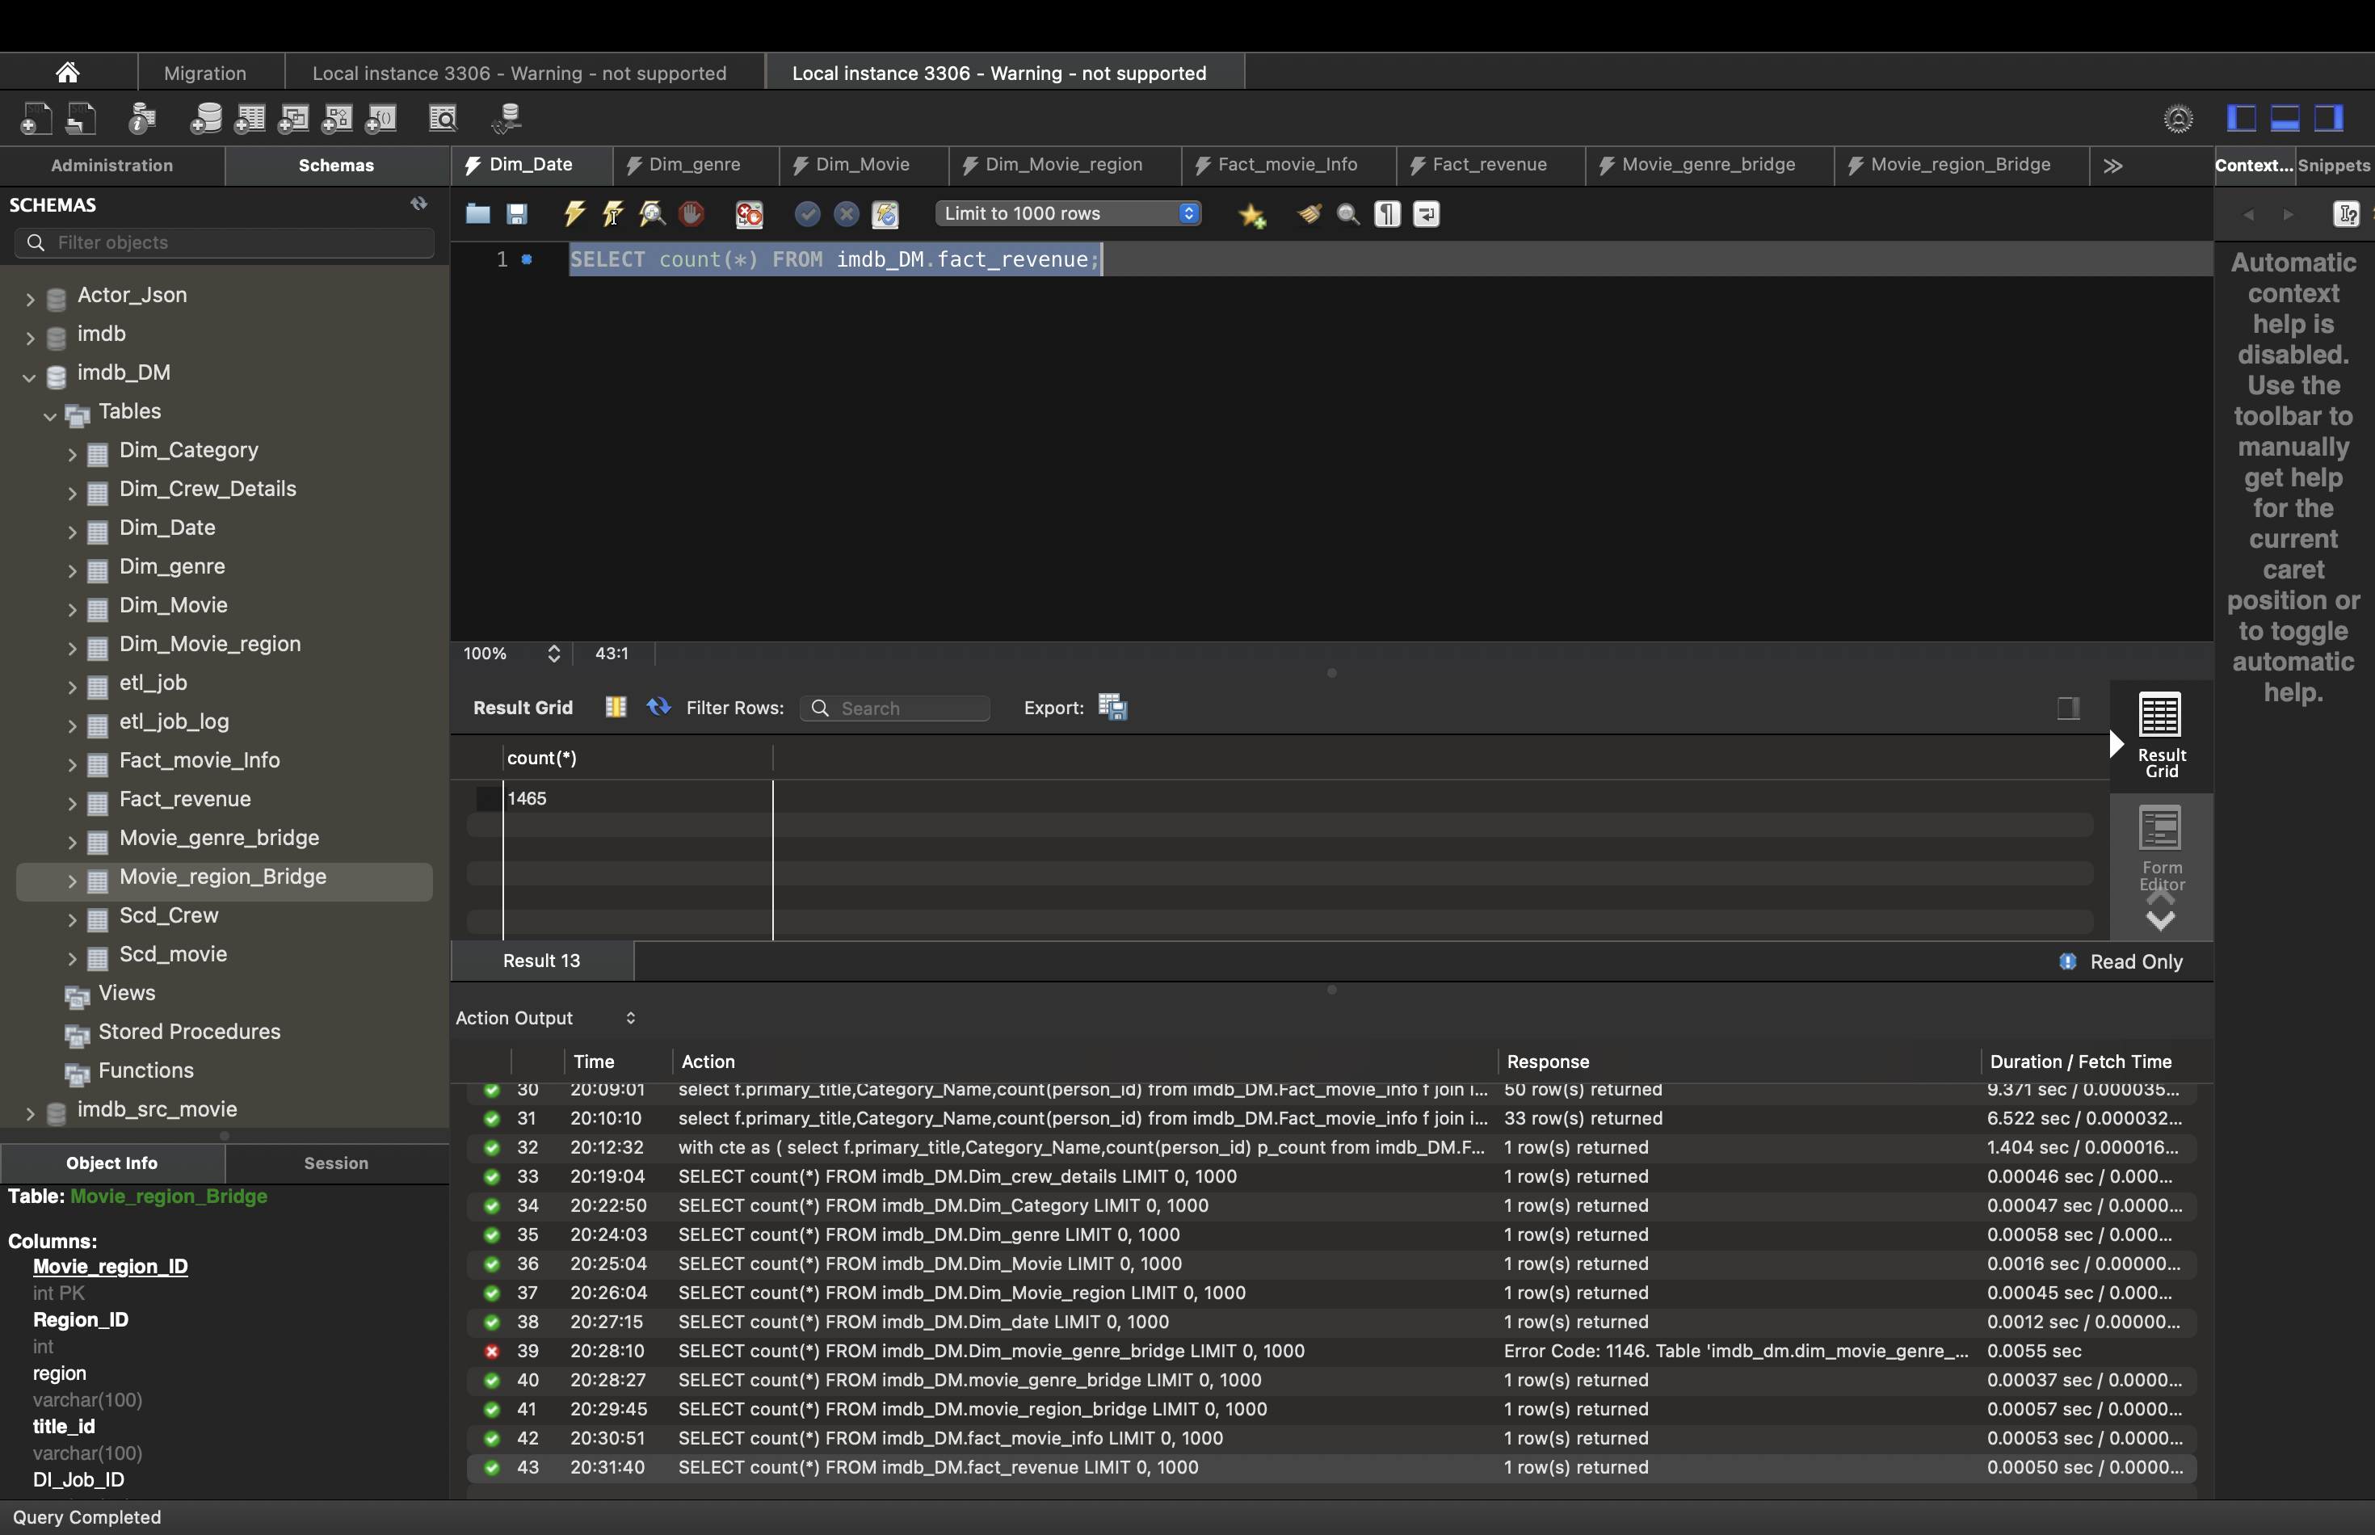  
  
  
BI Questions:**

**Trend Analysis:**

**1Average Movie Runtime over year**

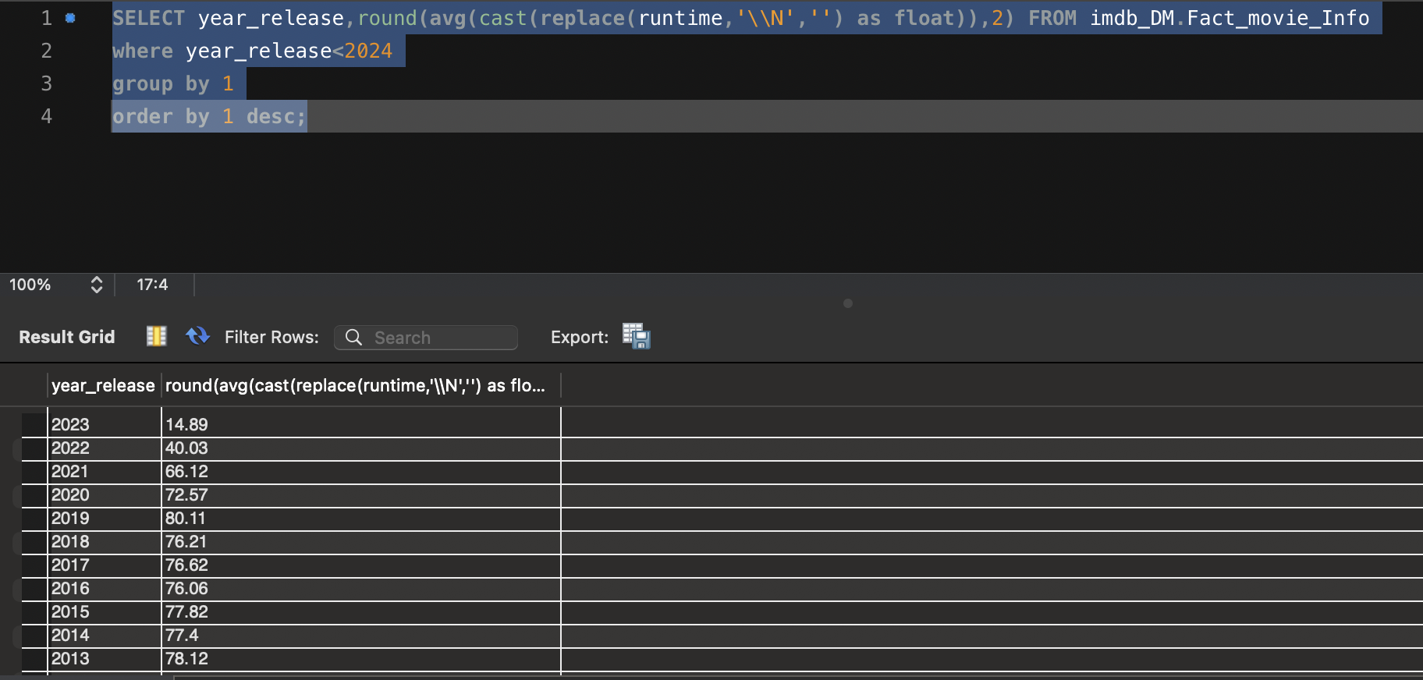

**2.Correlation Between avg rating and year release**

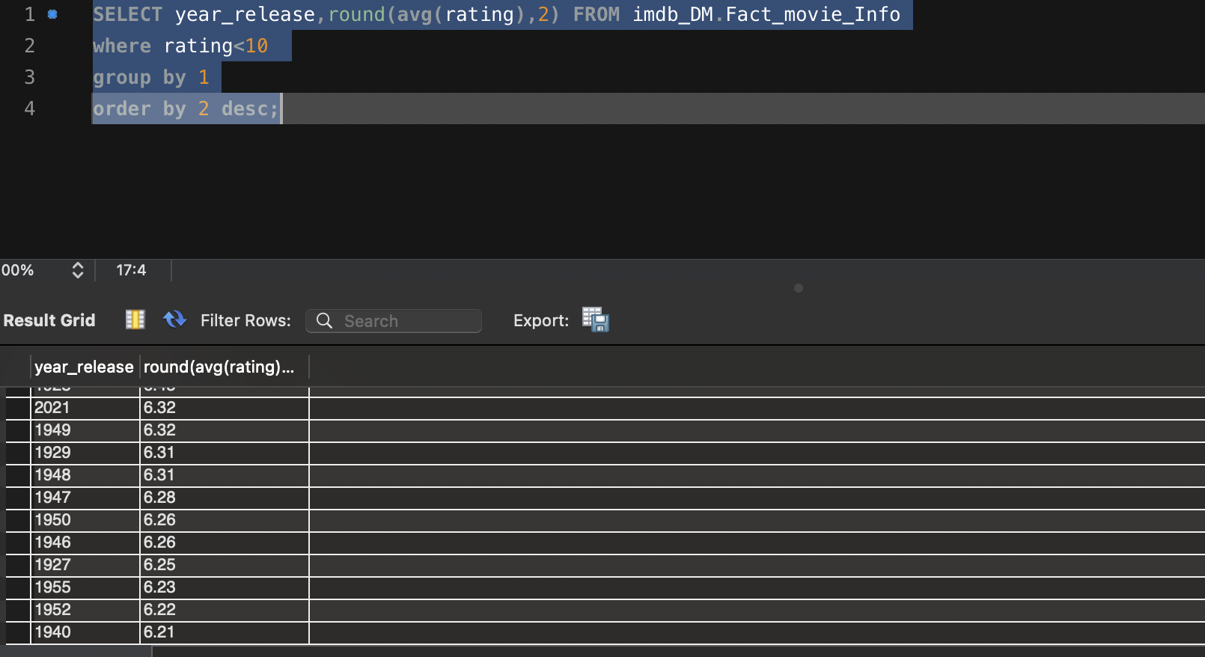

**3. Movie realease per year**



**2.Average Rating and year relation**

**Actor and Actress Film Record :**

**1)with cte as**

**(SELECT d.primary_name,**

**c.category_name,**

**count(primary_title),**

**rank()over(partition by c.category_name order by count(primary_title) desc) rnk**

**FROM imdb_DM.Fact_movie_Info f**

**join dim_crew_details d**

**on d.person_id = f.person_id**

**join dim_category c**

**on c.category_id = f.category_id**

**where c.category_name in ('actor','actress') and f.Rating between 4 and 7**

**group by 1,2**

**order by 2, 3 desc**

**)**

**select * from cte where rnk<11**

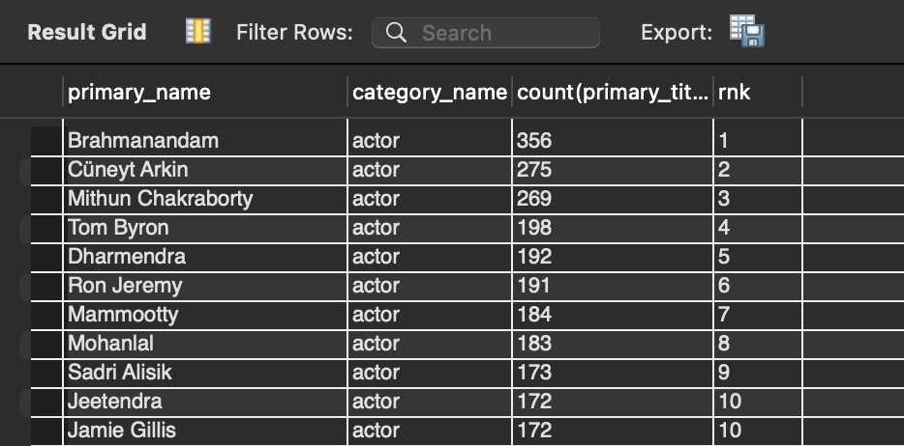

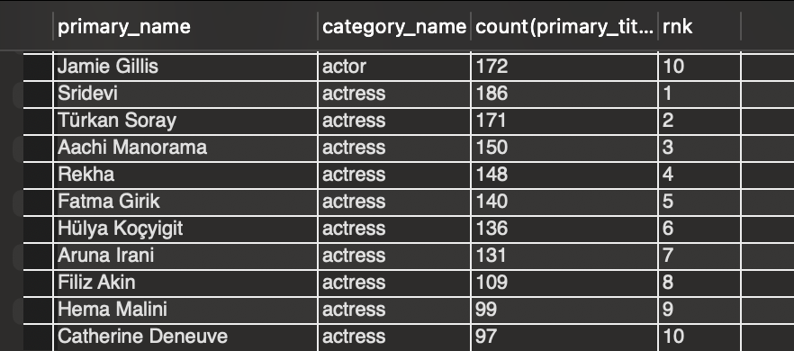

**Genre Analysis**

**Popularity of genre over the years**

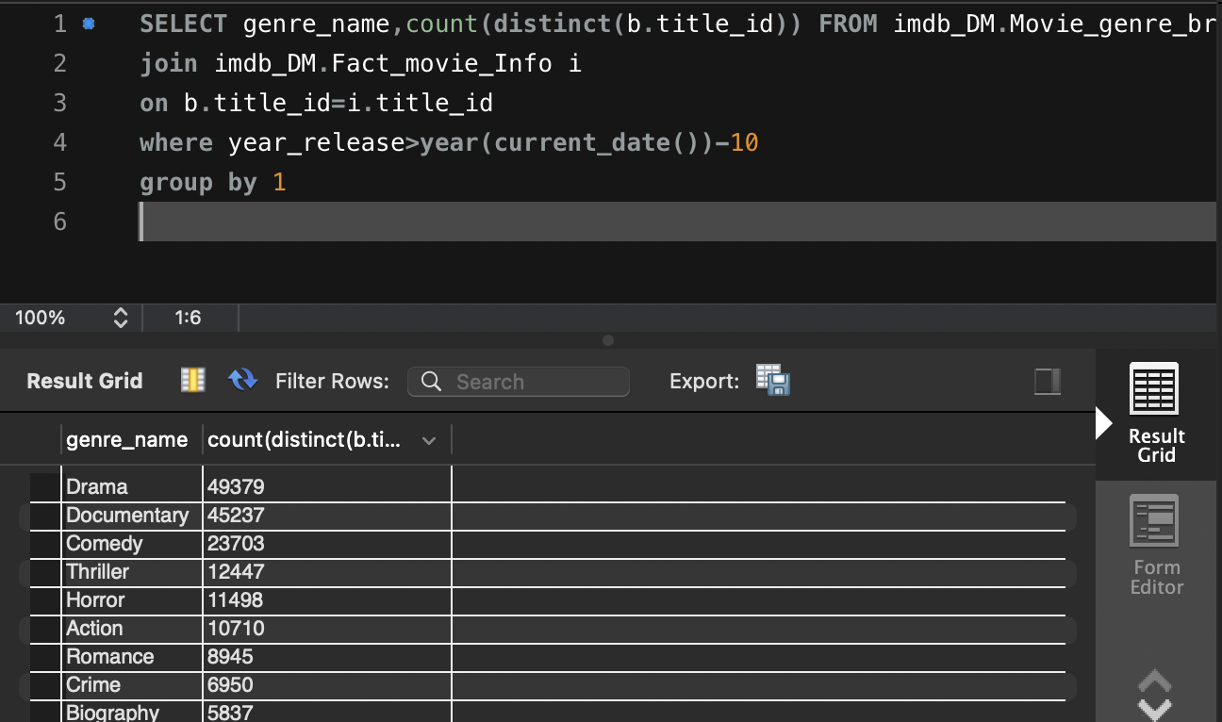

**Top 5 genres as compared to Gross Earning**

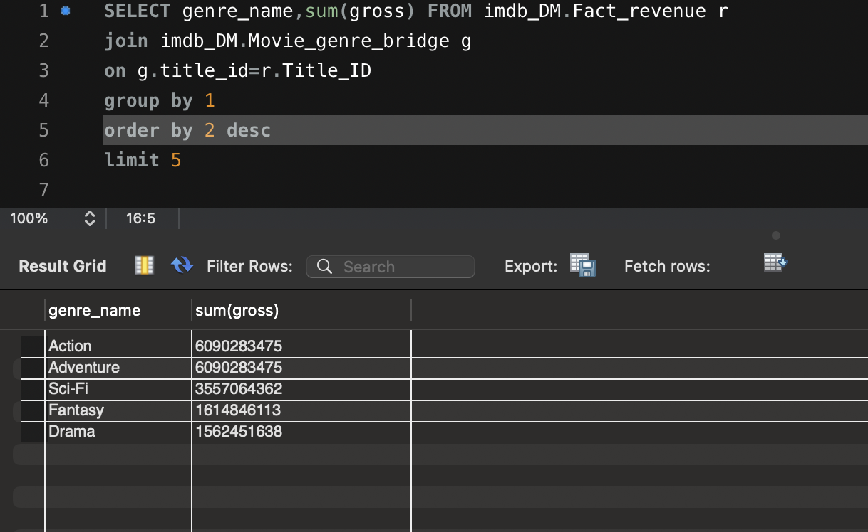

**Seasonal_Analysis**

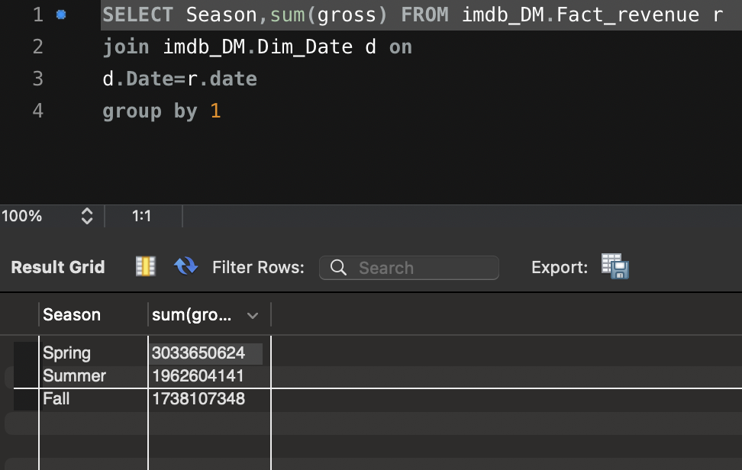

**2. top 3 movie based on season**

**with cte as**

**(SELECT season,primary_title,sum(gross),**

**row_number()over(partition by season order by sum(gross) desc)**

**rw FROM imdb_DM.Fact_revenue r**

**join imdb_DM.Dim_Date d on**

**d.Date=r.date**

**join imdb_DM.Dim_Movie m**

**on m.title_id=r.Title_ID**

**group by 1,2)**

**select * from cte where rw<4**

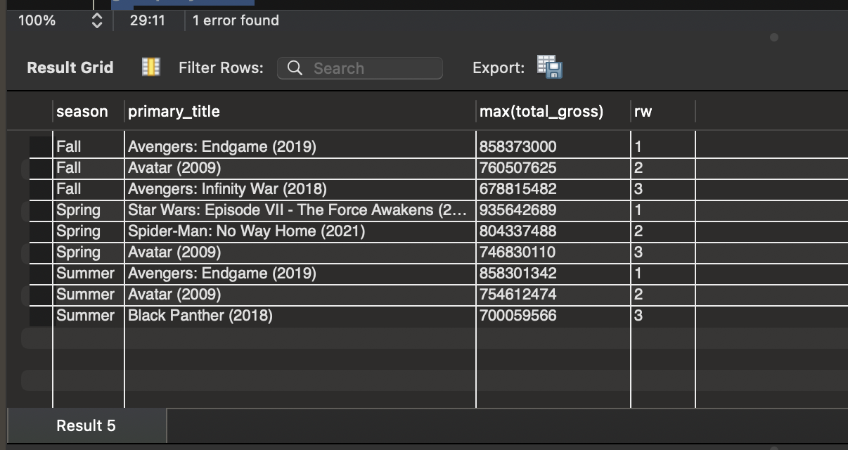

**Release Region:  
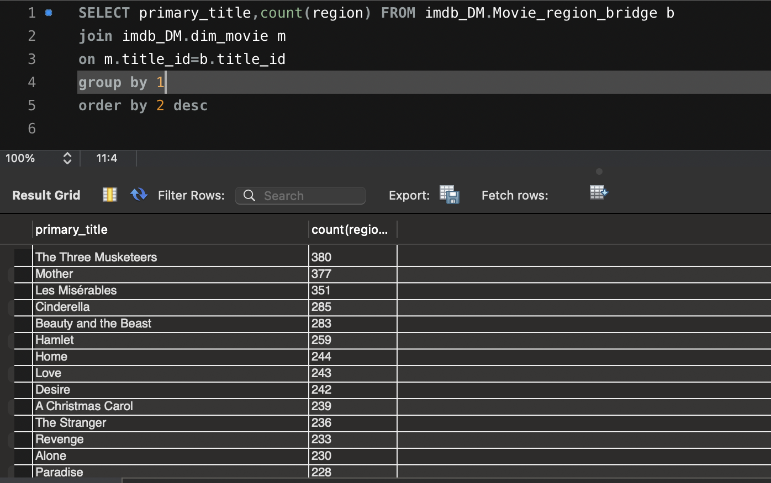**

**Matrix**

**with cte as (**

**select f.primary_title,Category_Name,count(person_id) p_count from imdb_DM.Fact_movie_info f**

**join imdb_DM.Dim_category c on**

**f.category_id=c.category_id**

**where title_id in (select distinct(Title_ID) from imdb_DM.fact_revenue) and Category_Name in('actress','actor','director','writer')**

**group by 1,2)**

**select sum(p_count) from cte**

**where Category_Name='director'**

**Director**

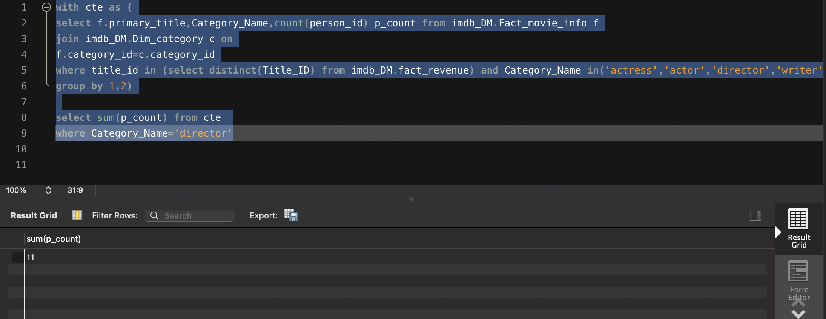

**Actor:  
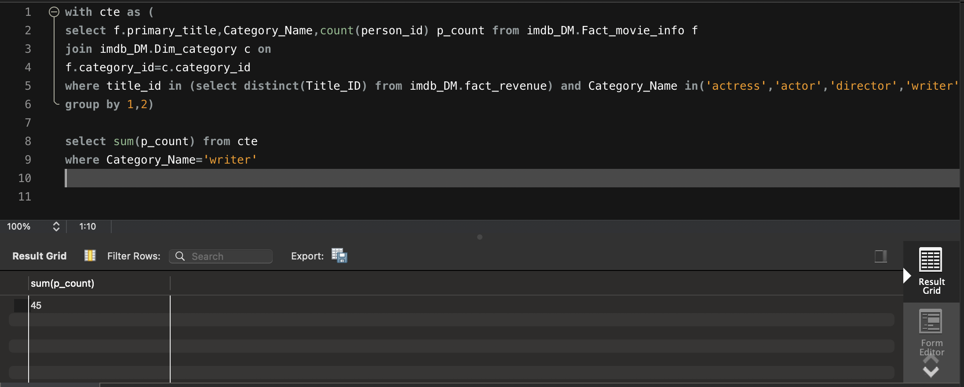**

**Similarly count for**

**Actress: 8, writers:24**

**Total_World Wide Gross Earning** 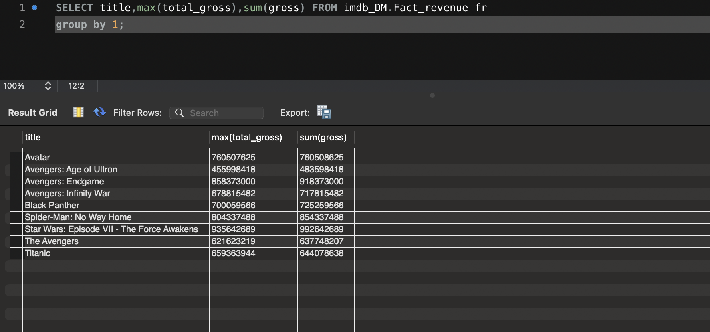

5.Average_Rating

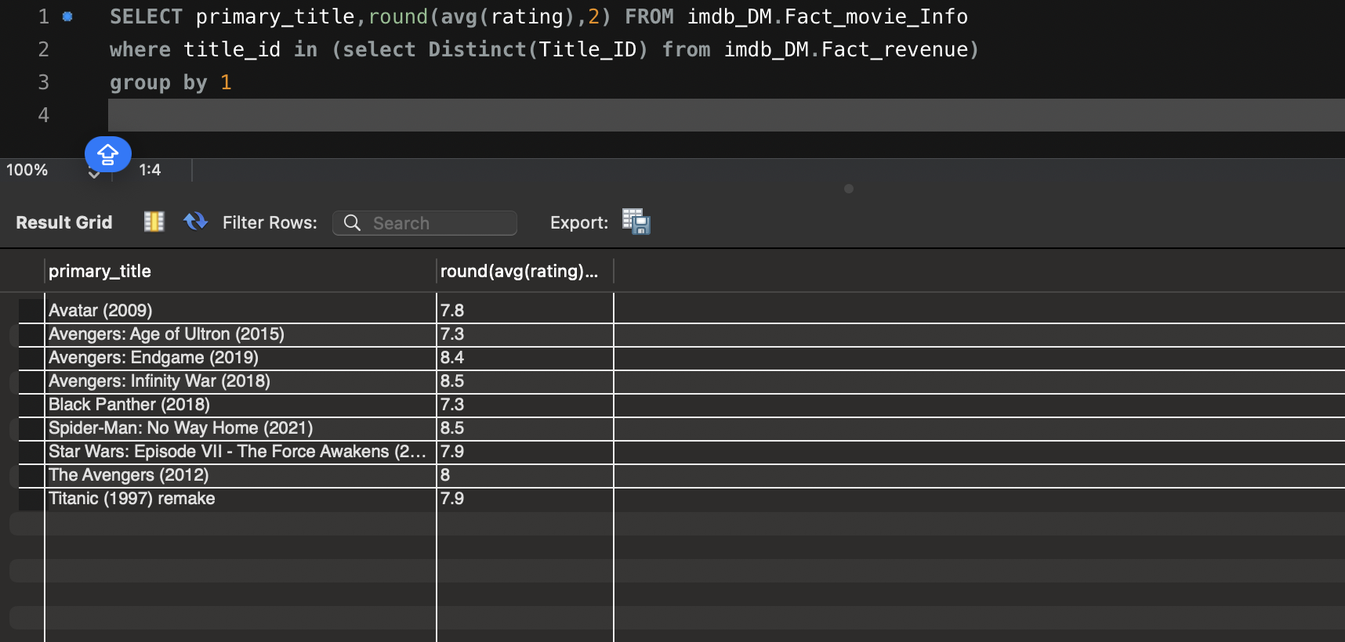

**No of Genre Per Movie**

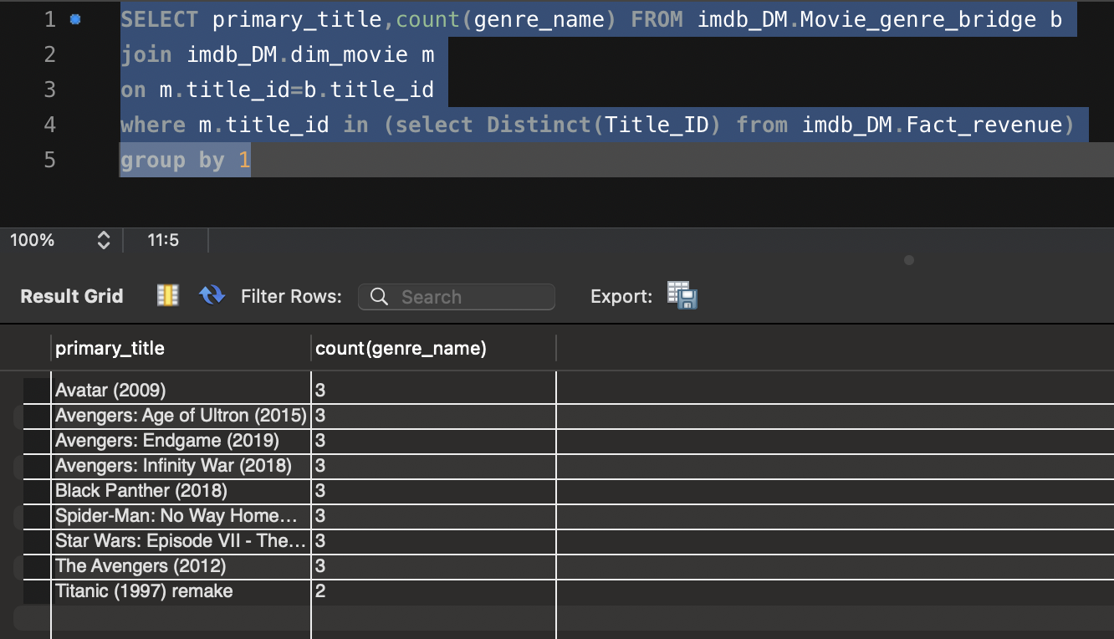

6 No of region,movie was released

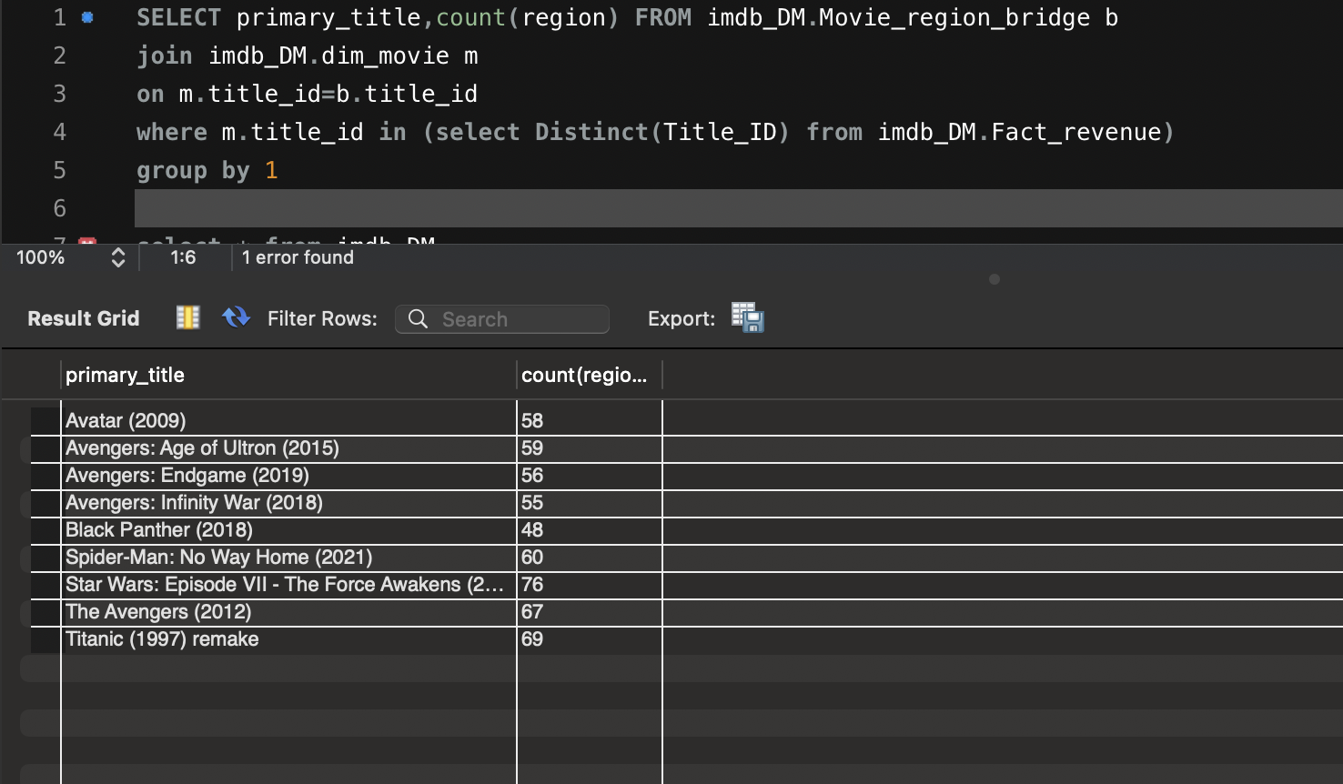

**ALTERYX Profiling**

**imdb_name_basics**

|  |  |  |  |
| --- | --- | --- | --- |
| column | max | min | Null% |
| nconst | 10 | 9 | 0 |
| Primary name | 95 | 1 | 0 |
| Birthyear | 4 | 2 | 0 |
| deathyear | 4 | 2 | 0 |
| Primary profession | 65 | 5 | 0 |
| Known for titles | 10 | 5 | 0 |

There are 265 birthyears which are below 1,800 and there are 1,208,402 records where the birthyear is ‘\n’

There are 1,35,378 records where there are ‘/n’ death years

Imdb_title_akas

|  |  |  |  |
| --- | --- | --- | --- |
| column | max | min | Null% |
| Title id | 10 | 9 | 0 |
| ordering | 149 | 1 | 0 |
| title | 273 | 1 | 0 |
| region | 4 | 2 | 0 |
| language | 3 | 2 | 0 |

Language contains 2177430 null values

Imdb_title_basics

|  |  |  |  |
| --- | --- | --- | --- |
| column | max | min | Null% |
| Tconst | 10 | 9 | 0 |
| Titletype | 5 | 5 | 0 |
| Primary title | 242 | 1 | 0 |
| Original title | 242 | 1 | 0 |
| startyear | 4 | 2 | 0 |
| endyear | 2 | 1 | 0 |
| runtimes | 5 | 1 | 0 |

There are 62 records which have a movie runtime of more than 300 minutes which is an abberation

Imdb_title_crew

|  |  |  |  |
| --- | --- | --- | --- |
| Column | Max | Min | Null% |
| directors | 29 | 2 | 0 |
| writers | 1189 | 2 | 0 |

The names for the writers and directors are not the conventional names its just abberations

Imdb_title_principle

|  |  |  |  |
| --- | --- | --- | --- |
| Column | Max | Min | Null% |
| ordering | 10 | 1 | 0 |
| category | 19 | 4 | 0 |
| job | 157 | 1 | 0 |
| titleID | 10 | 9 | 0 |